**The National Orthodox School /Shmaisani**

**Subject: Chemistry**

**Name: Fares Zumut Topic: States of matter**

**Date: 23/9/2022 Grade-Section: 6CS- all sections**

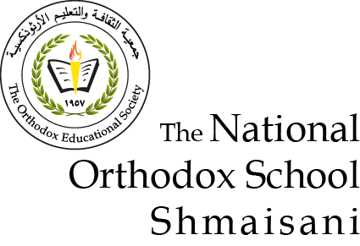

Starters

* Use the particle model to describe solid, liquids and gases and to explain the properties of solids and liquids.
* **Draw particle diagrams of solids and gases to model the arrangement of particles in the different states of matter.**

Solid liquid gas

|  |  |  |
| --- | --- | --- |
| OOOOOOOO | O O O O O O | O O O O |

Main course

**CHOOSE ONE DISH**

* Describe the processes of freezing and melting using the particle model and relate the processes to changes in temperature. (write between 50-70 words)
* **Make a table and write the difference between boiling and evaporation.**

|  |  |
| --- | --- |
| **Evaporation** | **Boiling** |
| The change of state from liquid to gas can happen at any temperature | The change of state from liquid to gas can only happen when the liquid is hot enough |
| The particles touch each other and they move around sliding over each other | Bubbles form around the liquid and in the bubbles the particles are spread out |
| Some particles move faster than the others the particles that move faster leave the surface of the water and the particles move away from each other forming gas | The bubbles go to the surface and pop |

Dessert

**CHOOSE ONE DISH**

* Draw the process of water cycle.
* **Draw a diagram that shows the changes in states and write the names of the processes on the arrows**. (be creative)

Evaporation Condensation precipitation

Lakes clouds land