**Name: Fares Zumut Homework: Food webs**

**Date: 23/9/2022 Grade-Section: 6 CS – All Sections**

**Objective: Identify the parts of a food chain and food web.**

**Question One:**

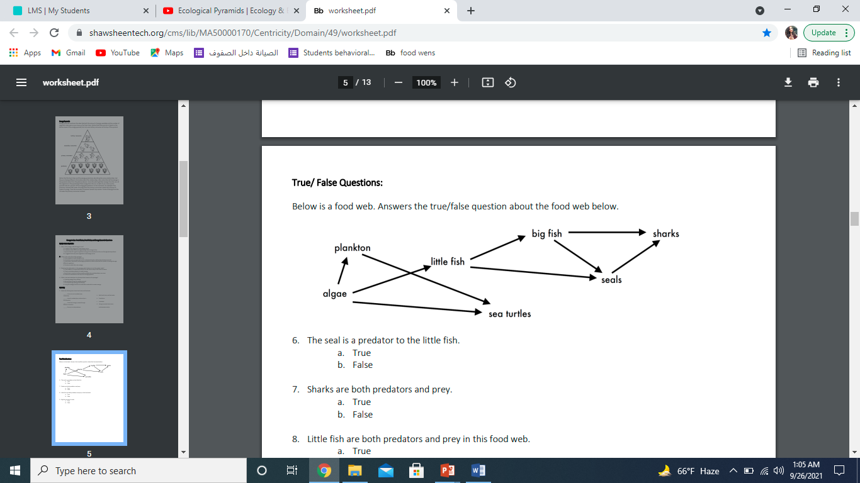Answer the following questions about the food web below.

1. The big fish is a predator to the **little fish.**
2. Which animals would have a bigger food supply if the number of little fish decreased? **Sea turtle**.
3. Which organism would have the least biomass in this food web? **Shark.**
4. Sharks are both predators and prey.

a. True

b. **False**

1. Decomposers are very important for life on Earth.

Explain what is the role of decomposers in food webs.

**Decomposers break down animals material and return its nutrients to the soil**