**Name: Laith Haddadin Homework: Food webs**

**Date: 23/09/22 Grade-Section: 6 CS – All Sections**

**Objective: Identify the parts of a food chain and food web.**

**Question One:**

Answer the following questions about the food web below.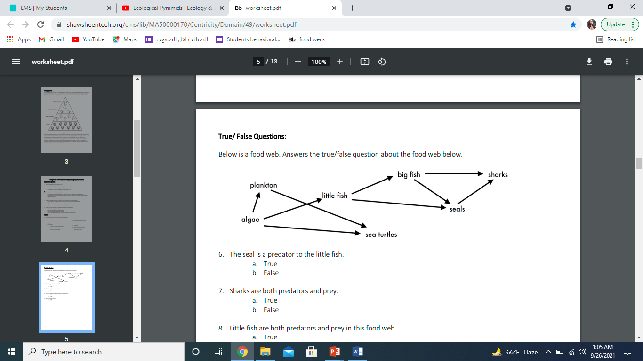

1. The big fish is a predator to the little fish.
2. Which animals would have a bigger food supply if the number of little fish decreased? Sea Turtles.
3. Which organism would have the least biomass in this food web? Sharks.
4. Sharks are both predators and prey.

a. True

b. False

1. Decomposers are very important for life on Earth.

Explain what is the role of decomposers in food webs.

They enable the bodies of organisms to be recycled, decomposers break down plant and animal material and return nutrients to the soil. These nutrients are taken up from the soil and used to help build new plants, the starting point of a new food chain.