**The National Orthodox School /Shmaisani**

**Subject: Chemistry**

**Name: Topic: States of matter**

**Date: Grade-Section: 6CS- all sections**



Starters

* Use the particle model to describe solid, liquids and gases and to explain the properties of solids and liquids.

-Draw particle diagrams of solids and gases to model the arrangement of particles in the different states of matter.

Main course

**CHOOSE ONE DISH**

* Describe the processes of freezing and melting using the particle model and relate the processes to changes in temperature. (write between 50-70 words)
* Make a table and write the difference between boiling and evaporation.

Dessert

**CHOOSE ONE DISH**

* Draw the process of water cycle.
* Draw a diagram that shows the changes in states and write the names of the processes on the arrows. (be creative)

Starters

|  |  |  |  |
| --- | --- | --- | --- |
|  | **solid** | **liquid** | **gas** |
| **Its particles are like** | Definite size and shape | No definite shape  It takes the shape any container | No definite shape  It takes the shape any container |
| **arrangement** | Regular | random | ramdom |
| **movement** | Vibrate about a fixed position | Move around each other | Move in all directions |
| **How far** | Very close | Close | Far apart |
| **Strength of particles** | Very strong | Strong | weak |

**Solid**

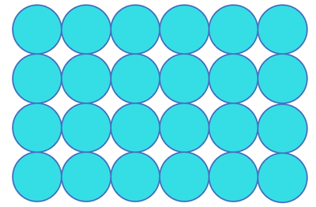

**Gas**



Main course

difference between boiling and evaporation

|  |  |
| --- | --- |
| Boiling | Evaporation |
| Change from liquid to gas state | Change from liquid to gas state without boiling |
| Fast process | Slow process |
| Bubbles are formed | No bubbles are formed |
| Occurs throughout the liquid | Takes place only from the surface of the liquid |
| Occurs at a definite temperature-boiling point | Occurs at all temperatures |

Dessert

the changes in states

melting boiling

Energy increases Energy increases

gas

liquid

solid

Energy decreases Energy decreases

freezing condensation