**The National Orthodox School /Shmaisani**

**Su/bject: Chemistry**

**Name: Randa Halteh Topic: States of matter**

**Date: Grade-Section: 6 F**

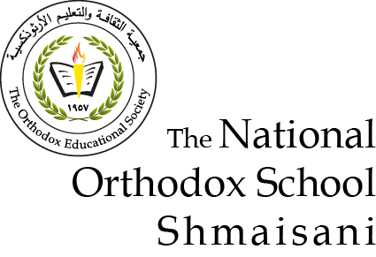

Starters

Use the particle model to describe solid, liquids and gases and to explain the properties of solids and liquids.

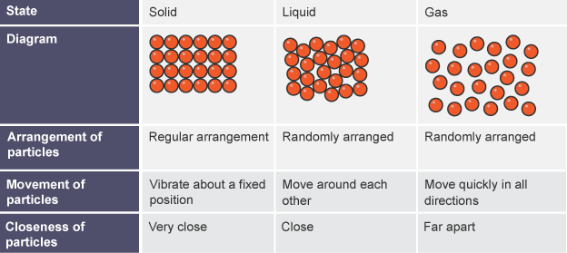

* Draw particle diagrams of solids and gases to model the arrangement of particles in the different states of matter.

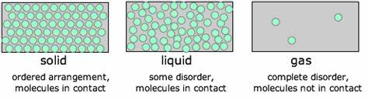

Main course

**CHOOSE ONE DISH**

* Describe the processes of freezing and melting using the particle model and elate the processes to changes in temperature. (write between words)

Make a table and write the difference between boiling and evaporation

|  |  |
| --- | --- |
| **Boiling** | **evaporating** |
| **A process in which a substance changes its state from the liquid state to the gas state** | **A process in which a substance changes its state from the liquid state to the gas state without boiling** |
| **faster** | **slower** |
| **Bubbles are formed** | **No bubbles formed** |
| **Occurs throughout the liquid** | **Takes place only from the exposed surface of the liquid** |
| **Occurs at a definite temperature Boiling point** | **Occurs at all temperatures** |

Dessert

**CHOOSE ONE DIS**

* Draw a diagram that shows the changes in states and write the names of the processes on the arrows. (be creative)

Draw the process of water cycle 