**The National Orthodox School /Shmaisani**

**Subject: Chemistry**

**Name: Michael said Topic: States of matter**

**Date: 22/9/2022 Grade-Section: 6CS-**



Starters

* Use the particle model to describe solid, liquids and gases and to explain the properties of solids and liquids.

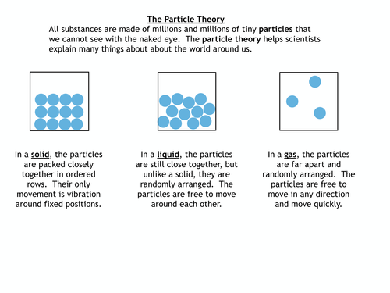

* Draw particle diagrams of solids and gases to model the arrangement of particles in the different states of matter. 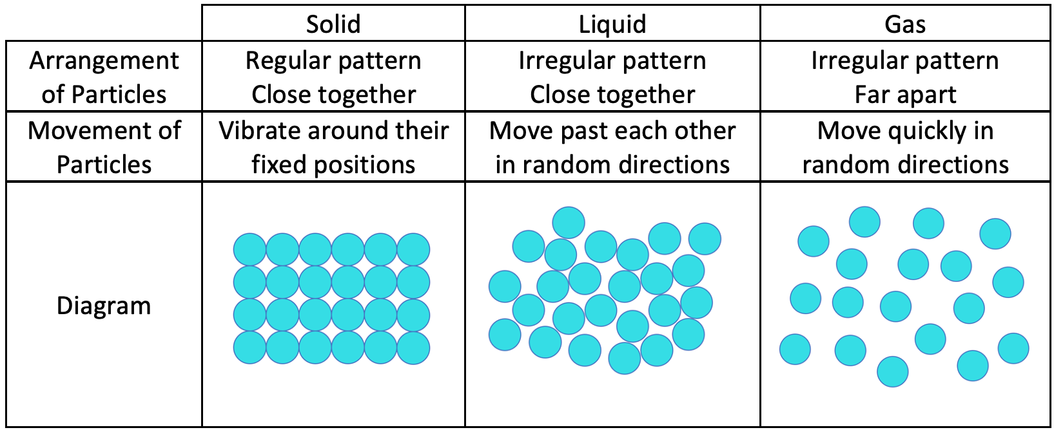

Main course

**Chicken and Vegetables**

* Describe the processes of freezing and melting using the particle model and relate the processes to changes in temperature. (write between 50-70 words).

Using frozen chicken and vegetables to prepare our main dish. Requires changing food substances state into room temperature to go through the process from freezing (where frozen food or solids gains energy to reach the melting state. Then when it reaches room temperature you start cooking in the oven to gain more energy and becomes solid and ready to serve. In other words, to change states of matter into another we need to add or remove of heat.

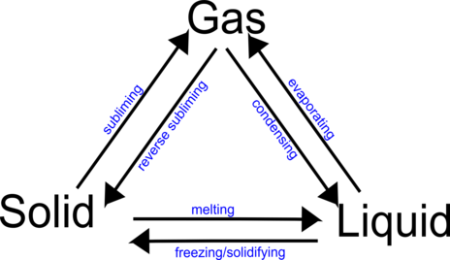

* Make a table and write the difference between boiling and evaporation.

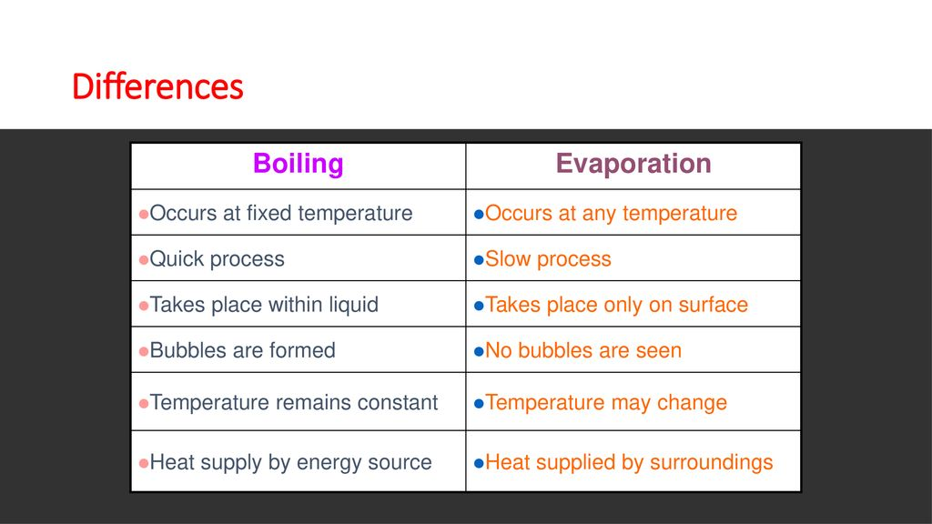

Dessert

**IceCream**

* the process of water cycle.

Water (Liquid) Ice (Freezing/Solid)

DECREASE TEMPRETURE

The state of strawberry milk or water at room temperature is liquid. However, we can change the state of its matter to IceCream by changing the temperature. Put the water mixture in the freezer to cooling 0ºC that turns the water into ice, which is solid. This is called the freezing point.

* Draw a diagram that shows the changes in states and write the names of the processes on the arrows.

