**The National Orthodox School /Shmaisani**

**Subject: Chemistry**

**Name: Abdullah khattab Topic: States of matter**

**Date: 21/9/2022 Grade-Section: 6CS- all sections**

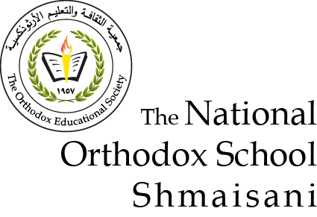

Starters

* Use the particle model to describe solid, liquids and gases and to explain the properties of solids and liquids.

1. Solid: solid particles are tightly packed, and they have a regular pattern. Solids have fixed shape, mass and volume, as they are the properties of solids.
2. Liquid: liquid particles are touching, but they are not in a pattern. Liquids have a fixed mass and volume, but not a fixed shape, these are the properties of liquids.
3. Gas: gas particles are far apart, and they don’t have a fixed shape.

* Draw particle diagrams of solids and gases to model the arrangement of particles in the different states of matter.

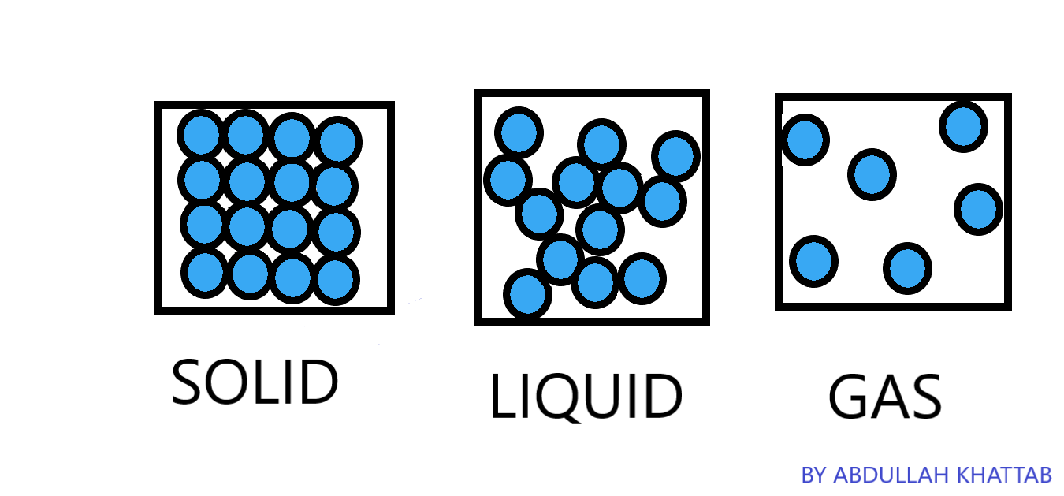

Main course

**CHOOSE ONE DISH**

* Make a table and write the difference between boiling and evaporation.

|  |  |
| --- | --- |
| Boiling | Evaporation |
| A process in which a substance changes its state from the liquid state to the gas state. | A process in which a substance changes its state from the liquid state to the gas state without boiling. |
| Fast | Slow |
| Bubbles are formed | No bubbles formed |
| Occurs throughout the liquid. | Takes place only from the exposed surface of the liquid. |
| Occurs at a definite temperature. Boiling point. | Occurs at all tempratures. |

Dessert

**CHOOSE ONE DISH**

* Draw the process of water cycle.

