Solids,liquids,gas

Solid. Liquids. gas

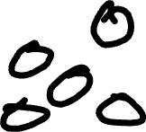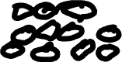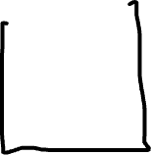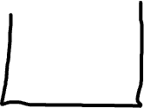

Freezing is when a liquid is cold enoph for it to freeze so it becomes ice hen I liquid. Is frozen it tuns onto an solid it first starts to get cold then after some time it starts to turn to a solid.

Melting is when a solid turns into a liquid it heats up to the point that it is very hot so it starts to melt so it turn onto a



Liquid

When it rains the water goes

To the oceans then it

Evaporates back onto the

Ocean.