**The National Orthodox School /Shmaisani**

**Subject: Chemistry**

**Name: Topic: States of matter**

**Date: Grade-Section: 6CS- all sections**

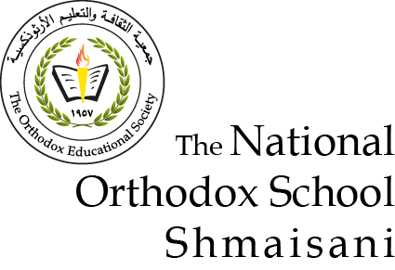

Starters

* Use the particle model to describe solid, liquids and gases and to explain the properties of solids and liquids.
* Draw particle diagrams of solids and gases to model the arrangement of particles in the different states of matter.

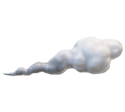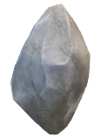

Main course

**CHOOSE ONE DISH**

* Describe the processes of freezing and melting using the particle model and relate the processes to changes in temperature. (write between 50-70 words)
* Make a table and write the difference between boiling and evaporation.

|  |  |
| --- | --- |
| boiling | eveperation |
| bubble | Doesn’t bubble |
| Not natural | natural |
| Happens From the bottom | Happens from the surface |

Dessert

**CHOOSE ONE DISH**

* Draw the process of water cycle.
* Draw a diagram that shows the changes in states and write the names of the processes on the arrows. (be creative)

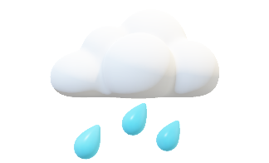

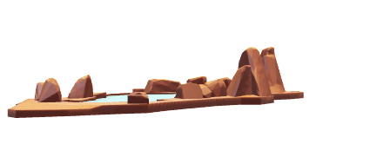

When the water from trees and lakes evaporate they go up causing rain to fall this filles up the lake again to then flow back to the tree and thus the water cycle