STOP

Cyber crime

cybercrime, also called computer crime, the use of a computer as an instrument to further illegal ends

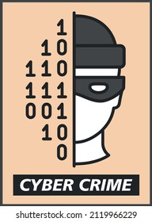 KEEP YOUR

PERSONAL

INFORMAION

Remember

Neve give your

* name
* Phone number
* Address
* Passwords