**Your laptop shuts down or freezes?**

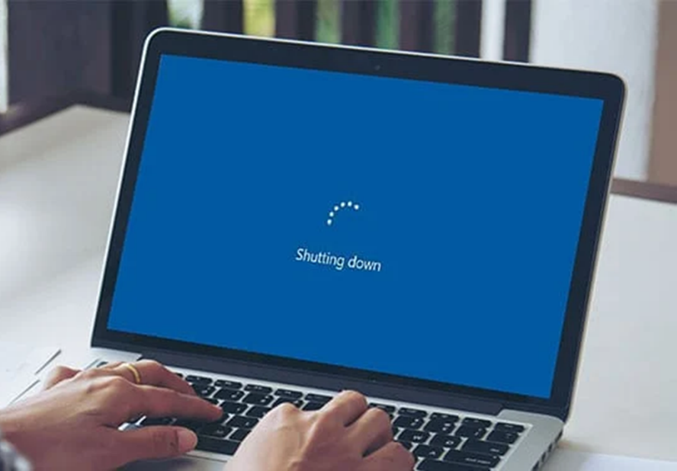

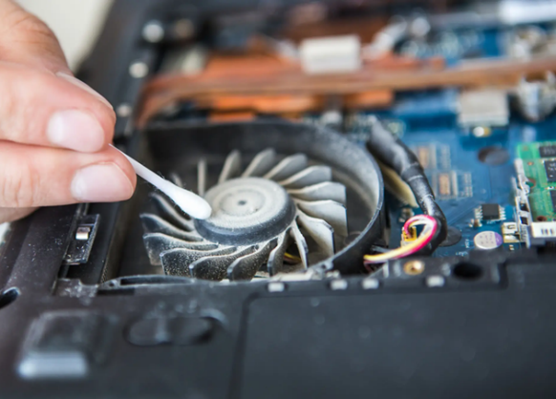

You get on your computer and start working, only for it to freeze a few minutes later or shut down on its own? I got you,

If your laptop shuts down or freezes, test the bottom. If it is hot or you notice the fan working harder than usual, the issue is likely related to heat. Clean out your fan and heat sink to prevent dust from clogging up and blocking the processor from cooling