**Name: Michael said Homework: Food webs**

**Date:22/9/2022 Grade-Section: 6 CS – All Sections**

**Objective: Identify the parts of a food chain and food web.**

**Question One:**

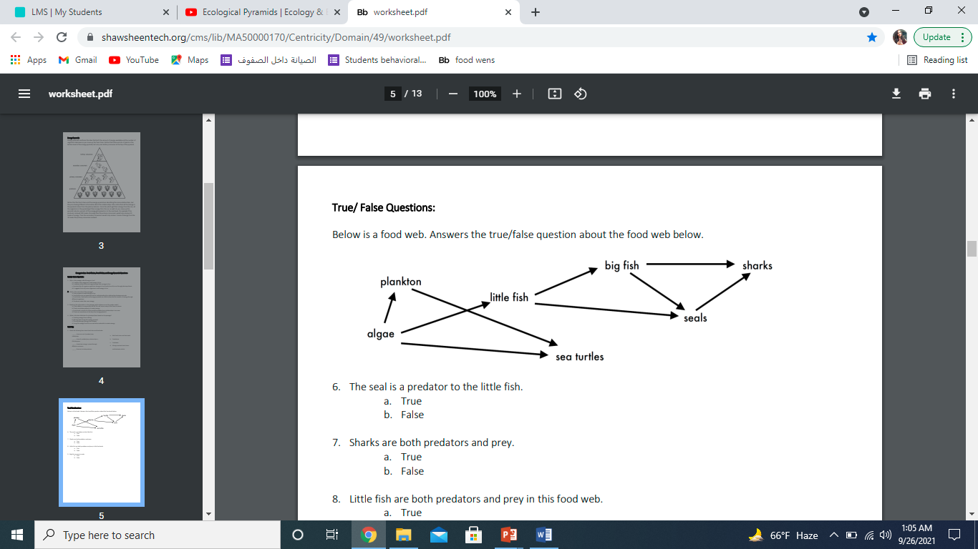Answer the following questions about the food web below.

1. The big fish is a predator to the __little fish______________________.
2. Which animals would have a bigger food supply if the number of little fish decreased? _sea turtles_______________________.
3. Which organism would have the least biomass in this food web? algae___________.
4. Sharks are both predators and prey.

a. True

b. False

1. Decomposers are very important for life on Earth.

Explain what is the role of decomposers in food webs.

___Decomposers are very tiny animals that eat the waste. Then they break the waste down into simple chemicals and nutrients.