**CYBERCRIME**

cybercrime, also called computer crime, the use of a computer as an instrument to further illegal ends, such as committing fraud, trafficking in child pornography and intellectual property, stealing identities, or violating privacy. Cybercrime, especially through the Internet, has grown in importance as the computer has become central to commerce, entertainment, and government.



Most cybercrime is an attack on information about individuals, corporations, or governments. Although the attacks do not take place on a physical body, they do take place on the personal or corporate virtual body, which is the set of informational attributes that define people and institutions on the Internet. In other words, in the digital age our virtual identities are essential elements of everyday life: we are a bundle of numbers and identifiers in multiple computer databases owned by governments and corporations. Cybercrime highlights the centrality of networked computers in our lives, as well as the fragility of such seemingly solid facts as individual identity.

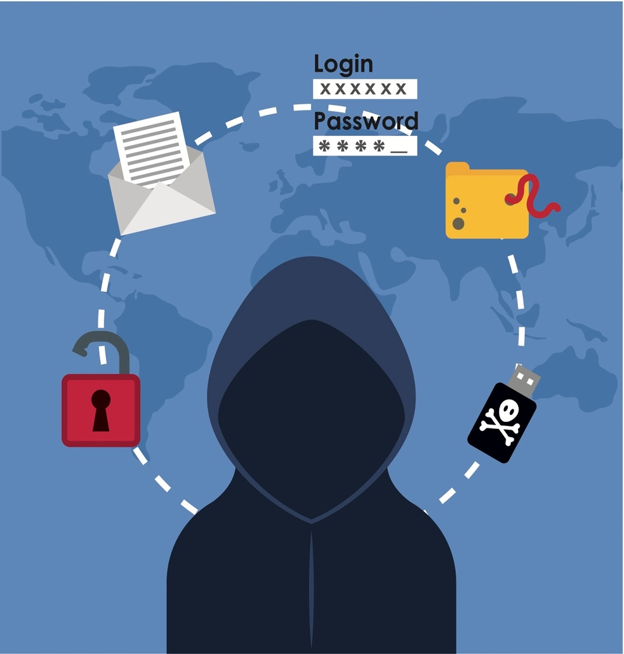

**Types of cybercrime:**

* **Cyberextortion:** A crime involving an attack or threat of an attack coupled with a demand for money to stop the attack.
* [**Cryptojacking**](https://www.techtarget.com/whatis/definition/cryptojacking)**:**An attack that uses scripts to mine cryptocurrencies within browsers without the user’s consent. Cryptojacking attacks may involve loading cryptocurrency mining software to the victim’s system
* [**Identity theft**](https://www.techtarget.com/searchsecurity/definition/identity-theft)**:** An attack that occurs when an individual accesses a computer to glean a user's personal information, which they then use to steal that person's identity or access their valuable accounts, such as banking and credit cards.
* [**Software piracy**](https://www.techtarget.com/whatis/definition/piracy)**:**An attack that involves the unlawful copying, distribution and use of software programs with the intention of commercial or personal use.

