**Phishing**

**What is a cyber crime?**

**A cybercrime is a cybercriminal who uses the internet to commit their crimes. We have four types of crimes they are: Identity theft, Phishing , Scamming ,Hacking .**



**What is Phishing?**

**Phishing is when a criminal makes a fake website which looks like official websites. When you open the website you will find a link which records your account and passwords and this could lead to loss a lot of money.**

**How to stay safe from Phishing?**

**To be able to stay safe from Phishing is at each of end of each link these should be written: .org , .jo , .com . Otherwise its all fake.**

**How to Know if your account is Phished?**

**Normally an Email tells the person who is receiving the email That there is a problem and logging in could solve the issue.**

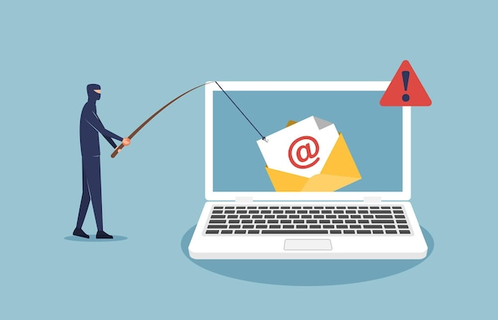

**Katia Ebaid 7e**