**Name: Teresa Al Rabadi Homework: Food webs**

**Date: 21/9/2022 Grade-Section: 6 CS – All Sections**

**Objective: Identify the parts of a food chain and food web.**

**Question One:**

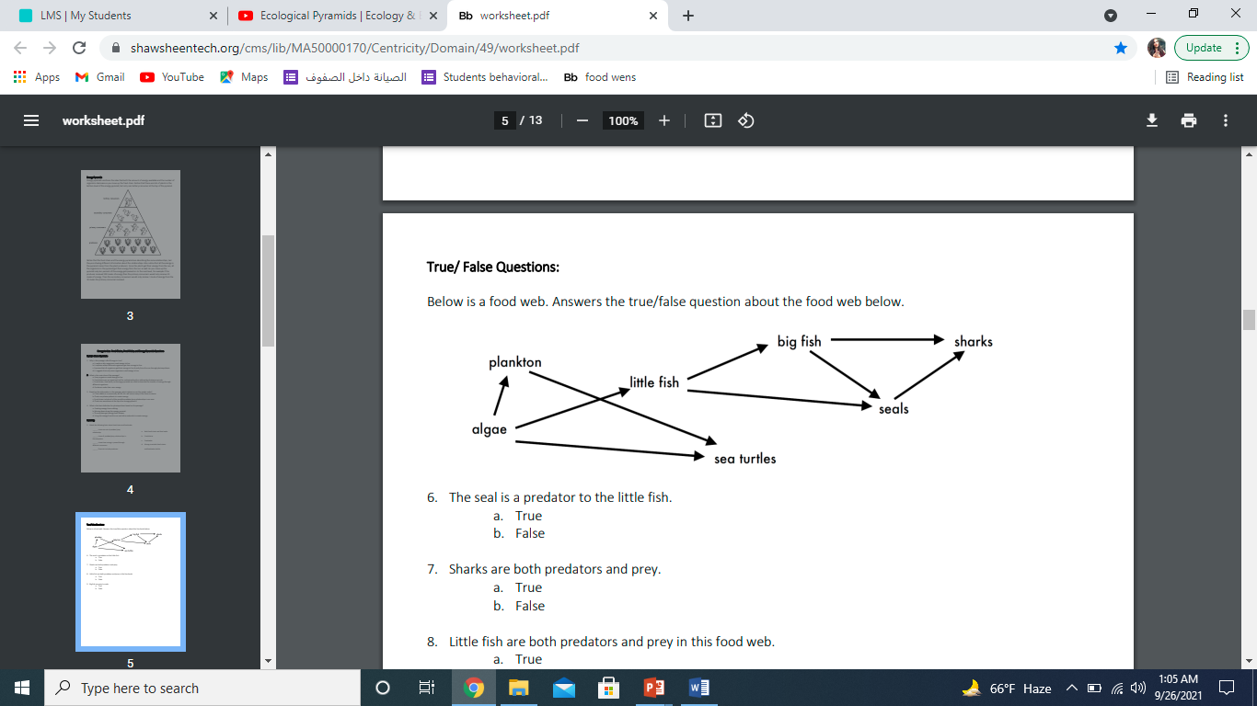Answer the following questions about the food web below.

1. The big fish is a predator to the Little fish.
2. Which animals would have a bigger food supply if the number of little fish decreased? Big fish ,seals .
3. Which organism would have the least biomass in this food web? sharks.
4. Sharks are both predators and prey.

a. True

b. False

1. Decomposers are very important for life on Earth.

Explain what the role of decomposers in food webs is.

Decomposers beak down dead animals , plants material and return the nutrients to the soil and they enable the bodies of organisms to be recycled

_______________________________________________________________________