Safety by: Abdullah Abujaber 8D

Safety: safety is one of the most important things in our daily life.

How can I stay safe while solving computer problems you may ask? 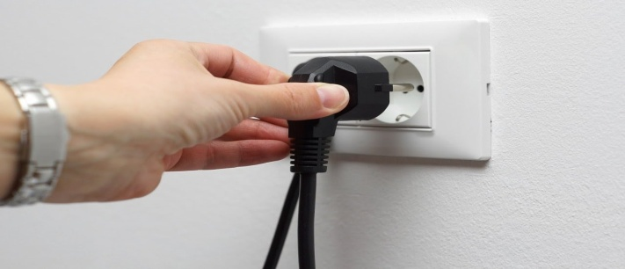

Here are some suggestions:

1. Close everything you have open before you switch off your device.

2. Do not open the case of your computer or any other device.

3. Never ever use force when plugging or unplugging cables.

4. Make sure all cables are unplugged from your device before moving it.

5. Dont lift heavy things like a computer alone.

6. If you can’t find a solution ASK for help.

