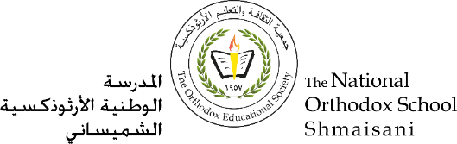

**The National Orthodox School /Shmaisani**

**Subject: Science/ Physics**

**Name: ………………………………… Title: Physics Homework**

**Grade-Section: 6 CS**

**Question 1:**

1. **Study the following diagrams A and B, and label them:**

**Diagram A:**

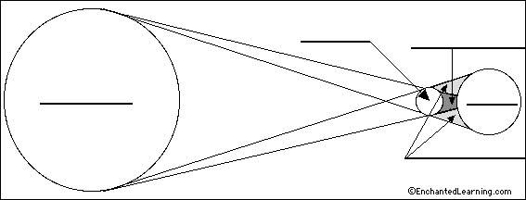

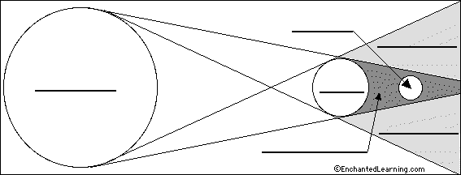**Diagram B:**

**Question 5:**

1. Which of the diagrams A, B shows a **solar eclipse**? …………………
2. Which of the diagrams A, B shows a **lunar eclipse**? …………………