**Name: Homework: Food webs**

**Date: Grade-Section: 6 CS – All Sections**

**Objective: Identify the parts of a food chain and food web.**

**Question One:**

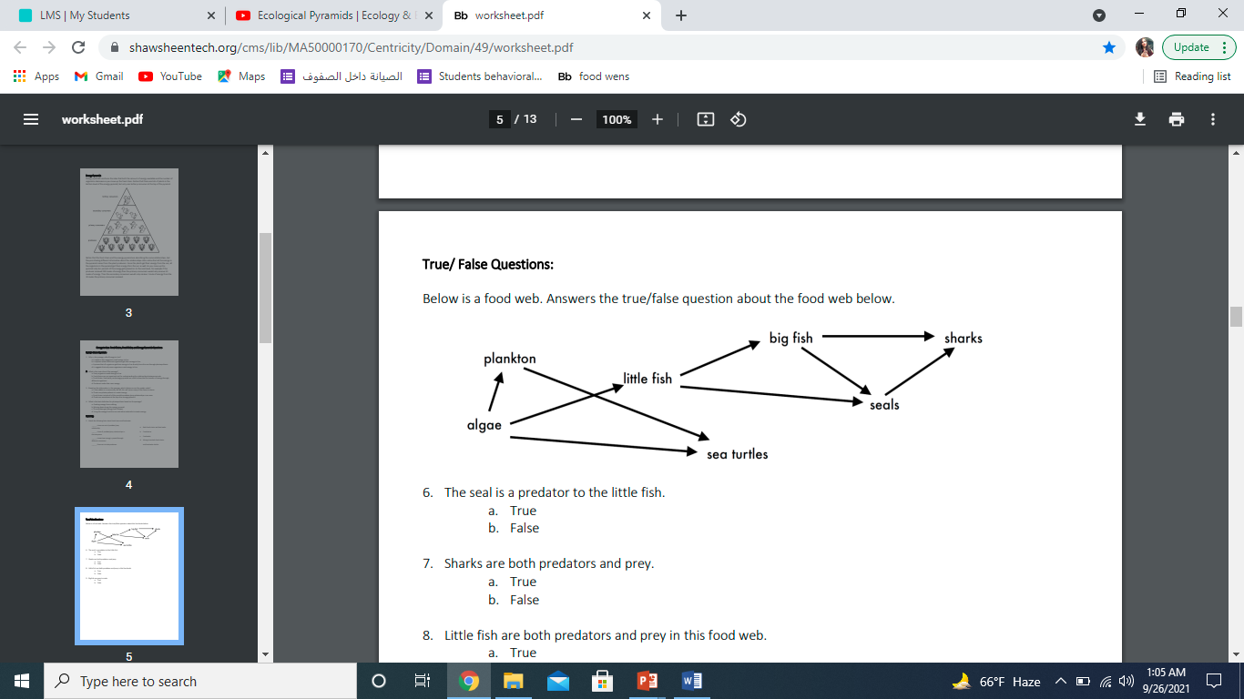Answer the following questions about the food web below.

1. The big fish is a predator to the **Shark and seals**
2. Which animals would have a bigger food supply if the number of little fish decreased **algae ,big fish, seals**
3. Which organism would have the least biomass in this food web **shark.**
4. Sharks are both predators and prey.

a. True (because the killer whale eats the shark (orcas)

b. False

1. Decomposers are very important for life on Earth.

Explain what is the role of decomposers in food webs.

They break down the waste and remains into simple chemicals and nutrients. And

They eat the waste and the remains of dead animals and plants