**Name: Noor Hijazin Homework: Food webs**

**Date: Grade-Section: 6 CS – All Sections**

**Objective: Identify the parts of a food chain and food web.**

**Question One:**

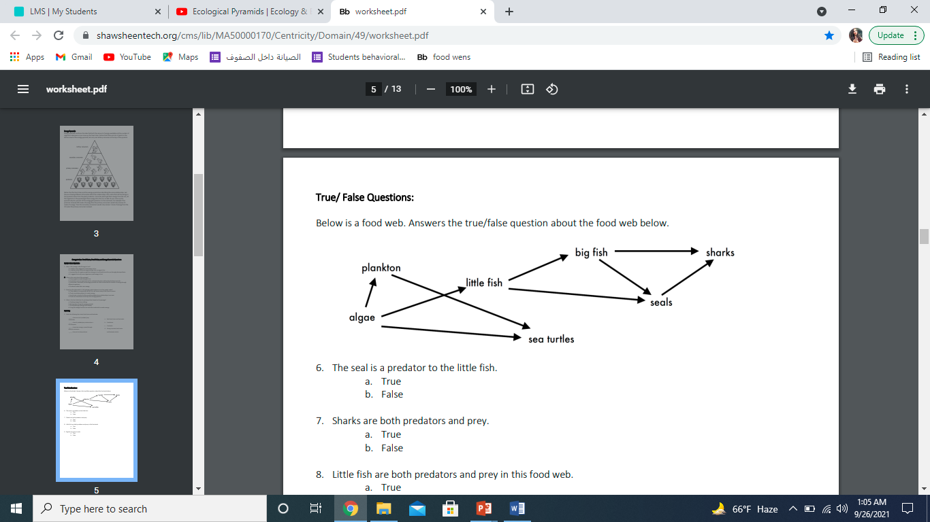Answer the following questions about the food web below.

1. The big fish is a predator to the _little fish_____________
2. Which animals would have a bigger food supply if the number of little fish decreased? ___plankton and sea turtles __________.
3. Which organism would have the least biomass in this food web? ___sharks____________.
4. Sharks are both predators and prey.

a. True

b. False

1. Decomposers are very important for life on Earth.

Explain what is the role of decomposers in food webs.

___when they feed on dead bodies they release nutrients to plants

And plants are producers and animals depend on plants

_____________________________________________________________________