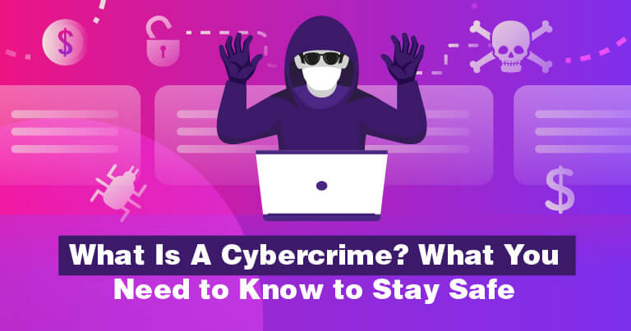

**What is cybercrime?**

Cybercrime is any criminal activity that involves a computer, networked device, or network.

**Types of cybercrime:**

* Identity fraud (where personal information is stolen and used).
* Theft of financial or card payment data.
* Email and internet fraud.

## How to Protect Yourself from Cybercrime Essay Sample | 123HelpMe.org**How to protect yourself against cybercrime:**

### **Use strong passwords**

Be sure to use strong passwords that people will not guess. Or use a reputable password manager to generate strong passwords randomly to make this easier.

### **Never open attachments in spam emails**

A classic way that computers get infected by malware attacks and other forms of cybercrime is via email attachments in spam emails. Never open an attachment from a sender you do not know.

### **Keep software and operating system updated**

Keeping your software and operating system up to date ensures that you benefit from the latest security patches to protect your computer.

