**The National Orthodox School /Shmaisani**

**Subject: Chemistry**

**Name: Topic: States of matter**

**Date: Grade-Section: 6CS- all sections**

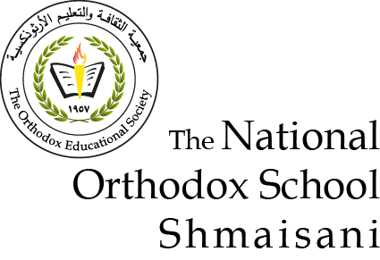

Starters

* Use the particle model to describe solid, liquids and gases and to explain the properties of solids and liquids.
* Draw particle diagrams of solids and gases to model the arrangement of particles in the different states of matter.

Main course

**CHOOSE ONE DISH**

* Describe the processes of freezing and melting using the particle model and relate the processes to changes in temperature. (write between 50-70 words)
* Make a table and write the difference between boiling and evaporation.

Dessert

**CHOOSE ONE DISH**

* Draw the process of water cycle.
* Draw a diagram that shows the changes in states and write the names of the processes on the arrows. (be creative)

Q1)

Solids Liquids Gasses

Q2cc

Gasses:

Particles are very far away from each other and are moving freely around the container

Solids: particles are vibrating in place and are very close to each other

Liquid: particles are partly close to each other and have a little space to move

|  |  |
| --- | --- |
| Boiling | Evaporation |
| Occurs throughout the liquid | Occurs only on the surface of the liquid |
| Formation of bubbles | No formation of bubbles |
| Consumes higher energy | Consumes lower energy |
| Occurs on high temperatures | Occurs on lowwer temperatures |

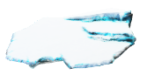 

freezing

condensation

Liquid: water

evaporation

melting

Solid: ice

Gas: water vapor

sublimation

sublimation