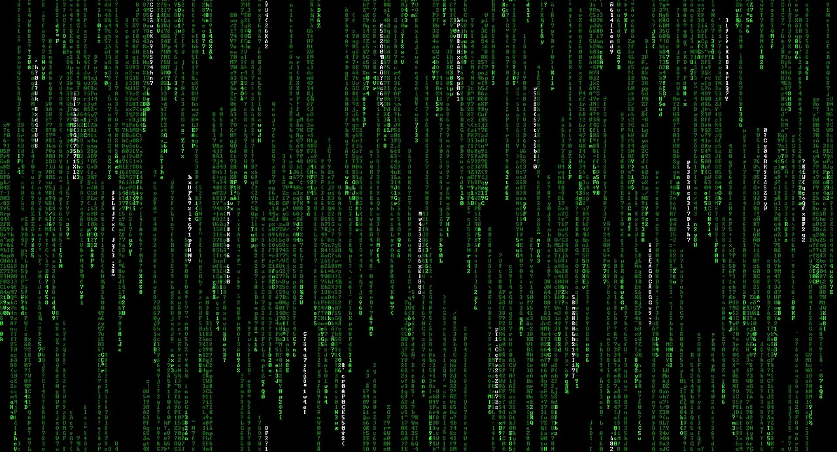

**Be responsible**

**Computers are kind of dangerous**

**Because they are devices that can be hacked and your info can be taken by hackers and you can lose a lot of accounts**

**Computers are devices that could be infected**

**With a virus, Trojan. And spy, ad and ransomware, etc**...

So, stay safe when you type or use a computer

Be careful, computers are not for people that doesn’t understand them

*caution*

Computers are sometimes

Dangerous because all your data could be lost with one click of a key