**The National Orthodox School /Shmaisani**

**Subject: Science/ Physics**



**Name: Title: Pressure Worksheet**



**Date: Grade-Section: 8- ……CS**



Question 1) A block of weight 850N has a length of 0.5 m and a width of 0.4 m and a height of 0.3 m.

1. Find the smallest pressure that this block exerts on the ground.

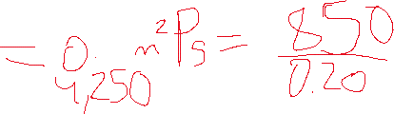

1. Find the largest pressure that this block exerts on the ground.

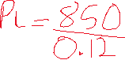

Question 2) The force applied to a 0.4 cm by 0.8 cm brake pad produces a pressure of 500 N/cm². Calculate the force applied to the brake pad.

