**The National Orthodox School /Shmaisani**

**Subject: Chemistry**

**Name: Topic: States of matter**

**Date: Grade-Section: 6CS- all sections**

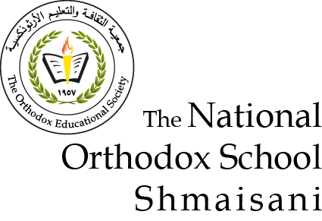

Starters

* Use the particle model to describe solid, liquids and gases and to explain the properties of solids and liquids.
* Draw particle diagrams of solids and gases to model the arrangement of particles in the different states of matter.

Main course

**CHOOSE ONE DISH**

* Describe the processes of freezing and melting using the particle model and relate the processes to changes in temperature. (write between 50-70 words)
* Make a table and write the difference between boiling and evaporation.

Dessert

**CHOOSE ONE DISH**

* Draw the process of water cycle.
* Draw a diagram that shows the changes in states and write the names of the processes on the arrows. (be creative)