**Name: Sama Ammari Homework: Food webs**

**Date: 9 /202022 Grade-Section: 6 CS – All Sections 6e**

**Objective: Identify the parts of a food chain and food web.**

**Question One:**

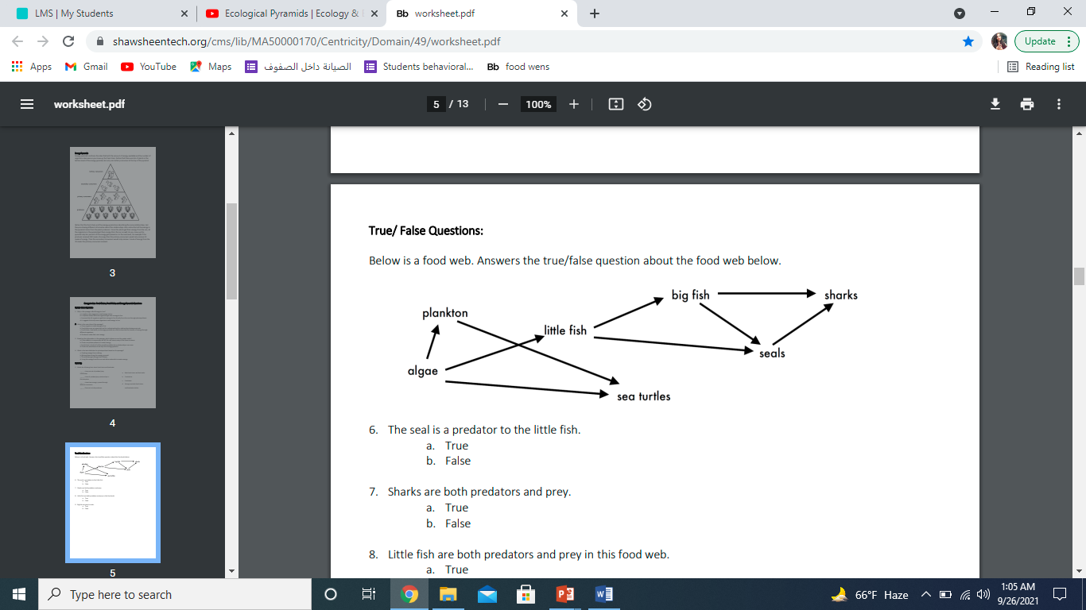Answer the following questions about the food web below.

1. The big fish is a predator to the sharks and seals
2. Which animals would have a bigger food supply if the number of little fish decreased? The algae
3. Which organism would have the least biomass in this food web? Sharks
4. Sharks are both predators and prey.

a. True

b. False

1. Decomposers are very important for life on Earth.

Explain what is the role of decomposers in food webs

Decomposers take all the energy and nutrients from the dead animals and give it to the soil that’s why they are really important