**Name: Karam Gammoh Homework: Food webs**

**Date: 19-9-2022 Grade-Section: 6 CS – All Sections**

**Objective: Identify the parts of a food chain and food web.**

**Question One:**

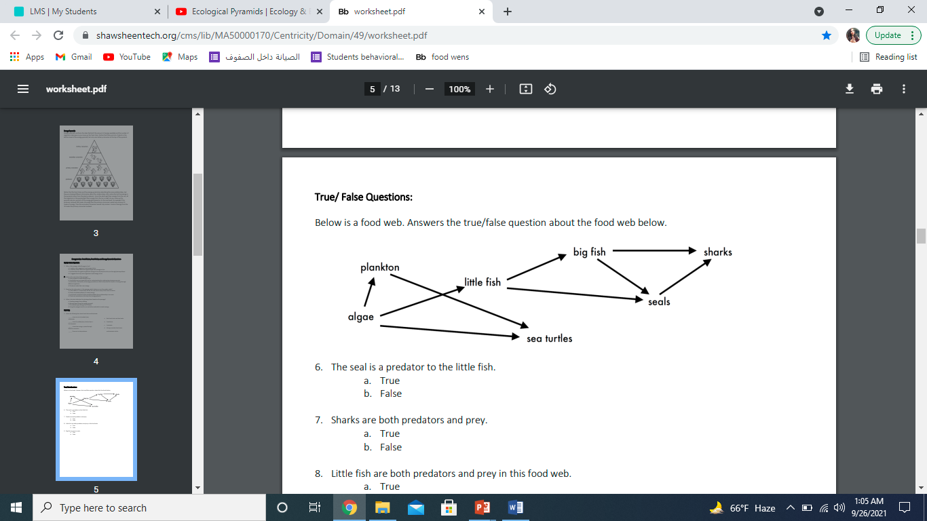Answer the following questions about the food web below.

1. The big fish is a predator to the _Little fish_.
2. Which animals would have a bigger food supply if the number of little fish decreased? ____big fish, seals___.
3. Which organism would have the least biomass in this food web? __algae___.
4. Sharks are both predators and prey.

a. True

b. False

1. Decomposers are very important for life on Earth.

Explain what is the role of decomposers in food webs.

_Decomposers break down plants and animals Martials and return to nutrients to the soil. So they enable bodies of organisms to be recycled. ___________________________________________________________________