**Name: Homework: Food webs**

**Date: Grade-Section: 6 CS – All Sections**

**Objective: Identify the parts of a food chain and food web.**

**Question One:**

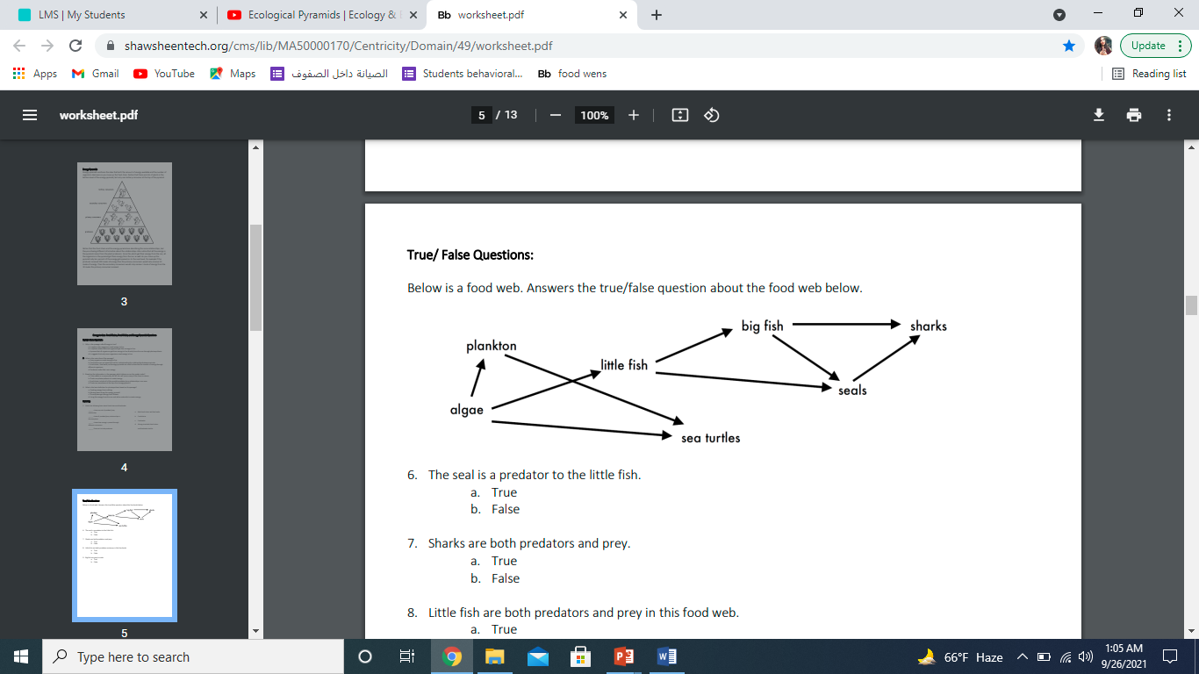Answer the following questions about the food web below.

1. The big fish is a predator to the _________SEALS_ shark______________.
2. Which animals would have a bigger food supply if the number of little fish decreased? __________sea turtules__, plankton__________.
3. Which organism would have the least biomass in this food web? _______________.
4. Sharks are both predators and prey.

a. True

b. False

1. Decomposers are very important for life on Earth.

Explain what is the role of decomposers in ____

_decomposers make compost which help plants to be bigger and better , and plants are the most important producers in a food web , They also break down the waste and remains into simple chemicals and nutrients so it will keep the environment

_________________________________________________________________