

**Activity – Design a Form**

**Name:Fares khoury …………………. 7th Grade / Section: _____**

**Date: 17/9/2022 1st Semester 2022/ 2023**

**Activity – Page 34**

Imagine you have designed a new website about your preferred computer game.

Your website has a chat room so that friends can discuss the game and share tips on how to play on how to play.

What information will you collect from your friends when they register?

1. User name
2. Birthday
3. Your favorite skin
4. Your score

Design a registration form to use on your website for registration.

Brawl Stars registration form

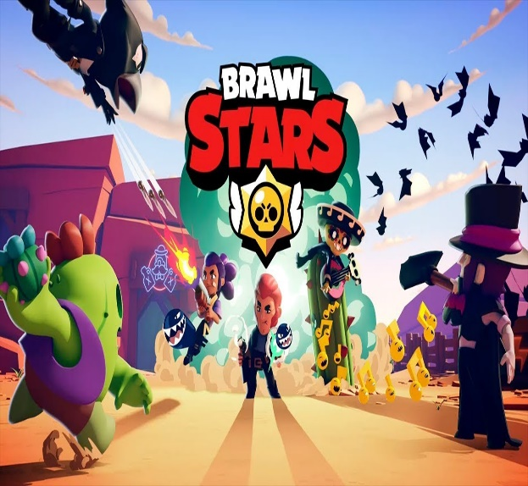

**Your favorite skin**

**Your score**

**Birthday**

**User name**