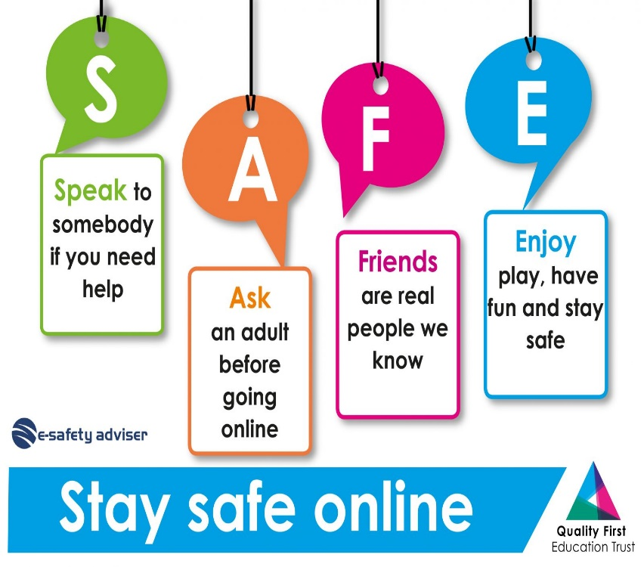tips to stay safe online :

-never lift heavy equipment alone .

-don’t open the case of your device to any other .

-make sure cables are disconnected before moving devices .

Reasons to stay safe online:

-Viruses can cause damage by deleting files and can allow criminals to monitor your computer and steal personal information.

-your device may get hacked and everything important may be destroyed .