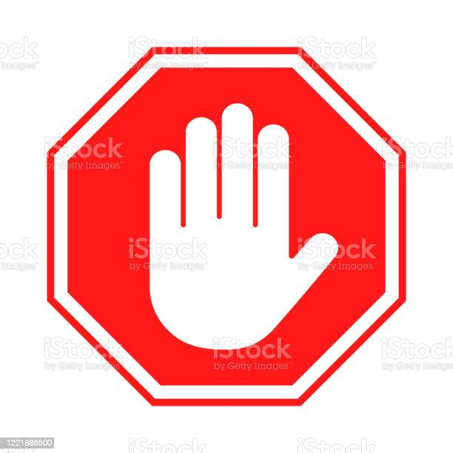 **Be careful**

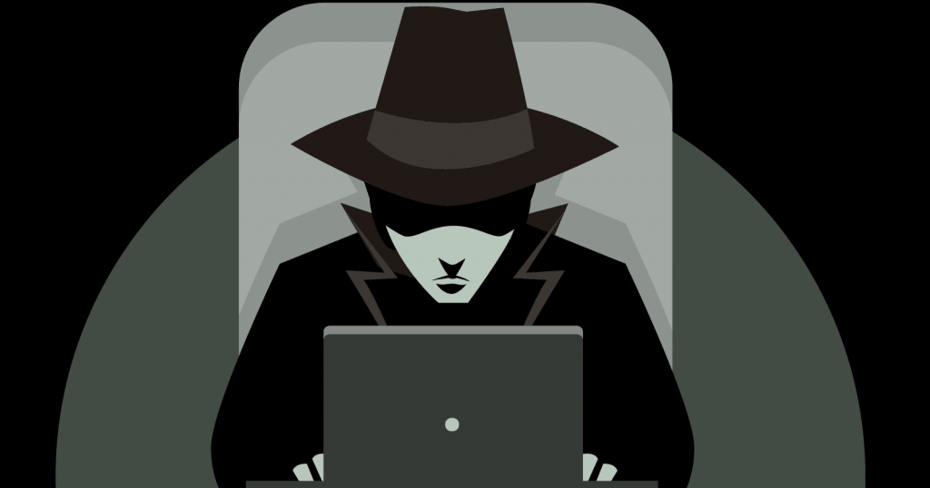

**Do not click on any emails that arrive in**

**unsolicited mail**

**pay attention to the warnings your**

**browser is flashing in your face**

**Have a different unique**

**Password**

**For every account**