**Do not click on any emails that arrive in *Be careful***

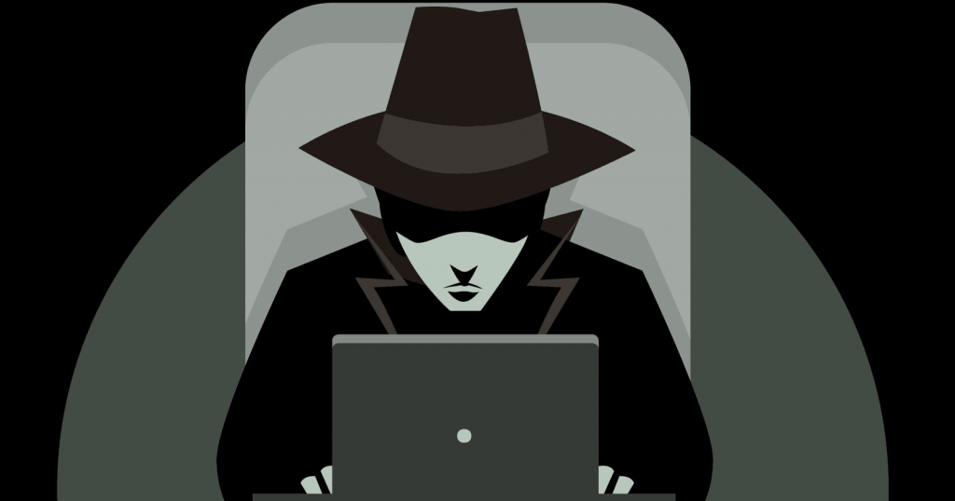 **unsolicited mail**

**pay attention to the warnings your**

**browser is flashing in your face**

**Have a different unique**

**Password**

**For every account**

**Change your passwords**

**often**