 Noah’s shop.

Ps4 300 jds

1200jdsiphone1.

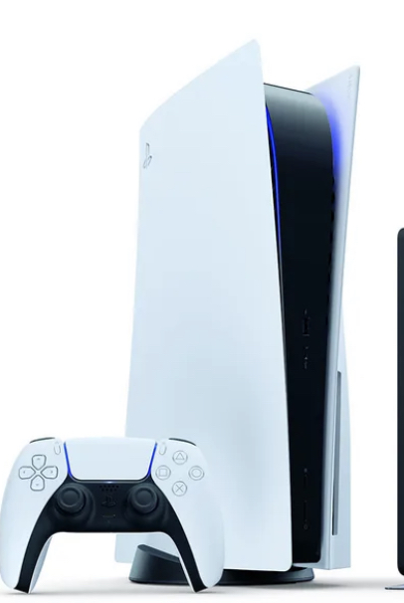 Ps5 550 jds

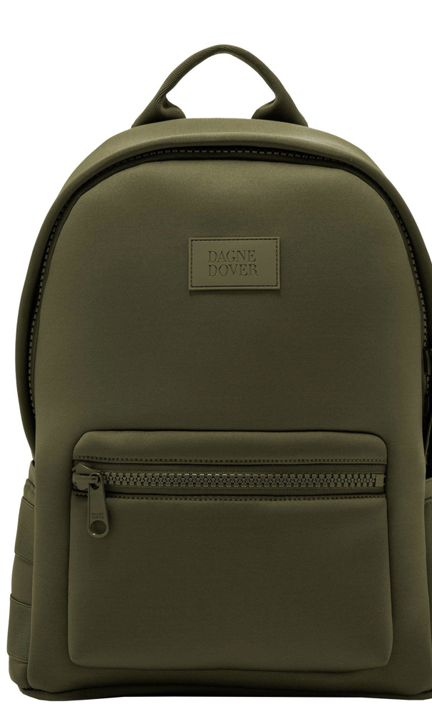20jds men bag.

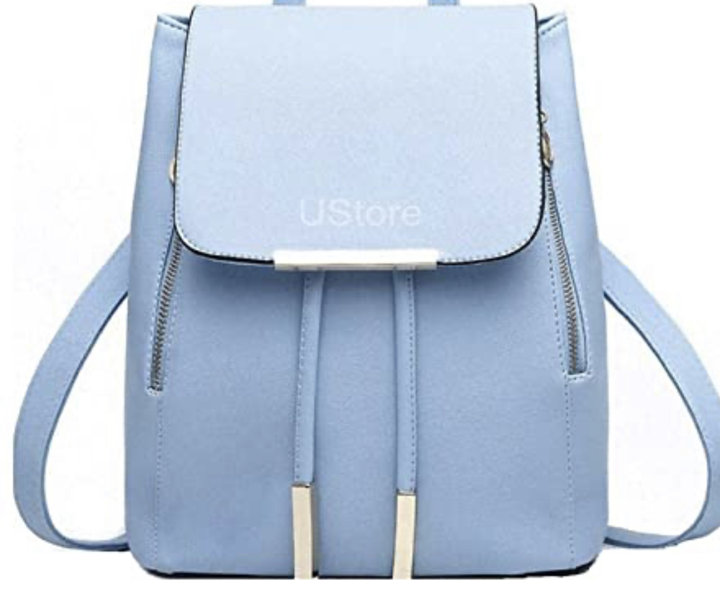 25jds women bag

Email:Abdullah.shtaiwi@nos.edu.jo

Password:Abdullah 12345

Phone number