Registration activity

First name

Last name

Username \*

Phone number

Email

Birth year

Password \*

Confirm password \*

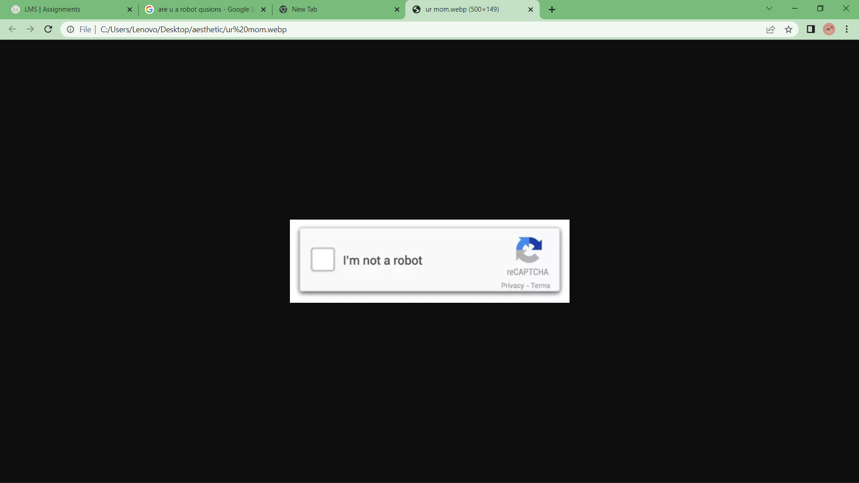

Submit