**Assignment#2 |** Lower Secondary

Stage (6-8)

1st Semester | 2023-2024

|  |  |
| --- | --- |
| **Subject:** ICT | **Chapter:** 5 |
| **Objectives:** Survey Analysis – create charts. | |

**The Student_ Information.xlsx includes information about students from   
grade 6 & 7, it was given to you so you can analyze the data and create charts.**

**Start**

Open the file **Student_ Information.xlsx** using MS-Excel and then apply the steps below:

* 1. Change the row height for Row#1 to 30 points.
  2. Set the width of column A, B, C and D to 12 points.
  3. In the range [A1:D 1] align the text: **center** and **middle**.
  4. Fill the range [A1:D1] with gray shade.

**Task 1**

* 1. Create a new sheet and rename to **[Task 1]**.
  2. In this sheet create the following tables.

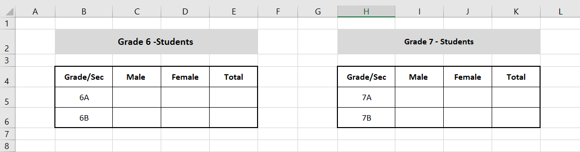

* + - * Merge the cells [B2:E2] and the cells [H2:K2]
      * Align the text in the merged cells to **center** and **middle**.
      * Fill the merged cells with a light blue shade.
      * Set the height of row#2 to 30
      * Set the height of row#4,5, and 6 to 25.
      * Set the width of the columns B&H to 12.
      * Set the width of the columns C, D, E and I, J, K to 10.
      * Align the text in the table to **center** and **middle**.
      * Add a border to the range [B4:E6].
      * Add a border to the range [H4:K6].
  1. Select the **Responses** sheet**.**

Use the data in the **Responses** Sheetand the **filter** featureto fill the created tables in **Task1** sheet with data.

**Select the range [A1:D1] and then select Data 🡪 Filter.**

* 1. In the cell E5 use a function to find the total number of male and female in grade 6A.

Repeat the same function in cell E6.

* 1. In the cell K5 use a function to find the total number of male and female in grade 7A.

Repeat the same function in cell K6.

* 1. Create a pie chart to show the percentage of students in Grade 6(A&B).
     1. Add a chart title "Percentage of grade 6-students in sections A and B"
     2. Show the legend
     3. Display the percentage on each sector.
  2. Create a pie chart to show the percentage of male and female in Grade 7B.
     1. Add a chart title "Percentage of male"
     2. Show the legend
     3. Display the percentage on each sector.