**Create Games Using Scratch**

It’s time to improve your skills, becreative and take your chance to create your own game using scratch.

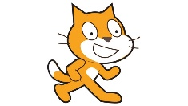I would really like to see what you come up with. All you need to do is try your hardest to make your game.

You can create Game for:

1. Entertainment: create a game to make fun.
2. 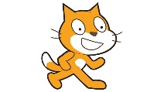Create an educational Game such as:
   1. Math Game
   2. Recognizing Letters
   3. Differentiate shapes (triangle, square, circle, …etc.)

**Competition rules**

1. Each game should be created with Scratch.
2. You can work alone or in pairs.
3. The game must include suitable characters and backdrops.
4. The game must include **more than one level**.
5. The key commands must be clear for the player
6. The idea is original (not copied from scratch).
7. The scenarios should be catchy and simple to understand and the game should not be endless.
8. There should be a main objective which, once fulfilled, the game should come to an end
9. The competition is open to students in Grade 6.
10. Upload your project on LMS assignment (Scratch Competition), take into consideration that this task is optional.
11. Don’t Copy any idea from Scratch Gallery.
12. 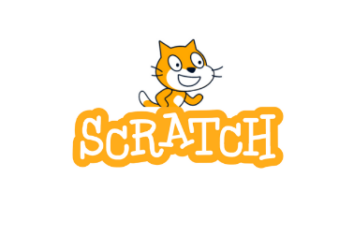Send your project by **15/1/2024** (LMS Assignment)

**Rewards:**

The best three projects will be rewarder.