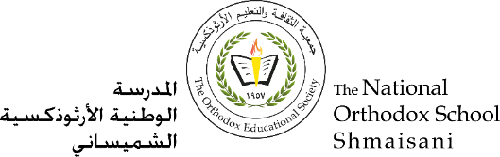

**The Primary Stage of Grades (4-5)**

**School Year 2022- 2023**

**Name**: ___________ **Subject**: **English Language**

Spelling Worksheet #4

**Date: / / Class: Grade 5CP (_______)**

# Objective: to spell comparative and superlative adjectives correctly

# Comparatives and Superlatives

We use **Comparatives** and **Superlatives** to compare two or more nouns.

The formation of the comparative and superlative depends on the number of syllables in the adjective:

### One-syllable Adjectives

To form the comparative, we add **-er** to the end of the adjective.

To form the superlative, we add **-est** to the end of the adjective.

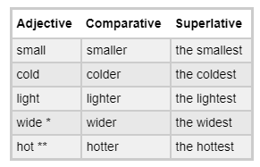

* When an adjective ends in the letter E, we just add the -R (for comparatives) or -ST (for superlatives). We do not write two Es together. **Wider** (correct) not wideer (incorrect).

** When an adjective ends in a consonant + short vowel + consonant (C + V + C), we normally double the last letter. big - bi**gg**er - bi**gg**est, wet - we**tt**er - we**tt**est

* 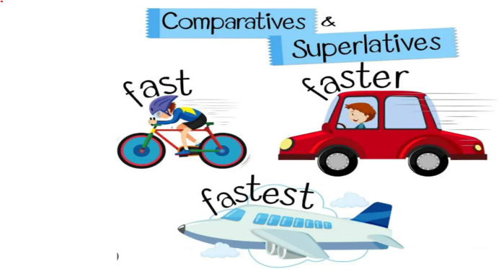London is **bigger than** Santiago.
* Mike is **taller than** John but James is **the tallest**.
* Yesterday was **the hottest** day of the year.
* It is **the oldest** building in the village.
* I want a **faster** car.

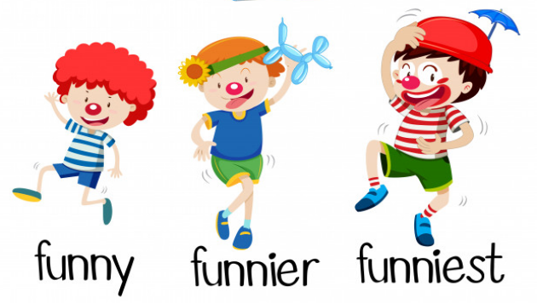Notice how comparatives are often followed by **than** when comparing two things or people.

### Two-syllable Adjectives ending in -Y

To form the comparative, we remove the -y and add -**ier** to the end of the adjective.

To form the superlative, we remove the -y and add -**iest** to the end of the adjective.

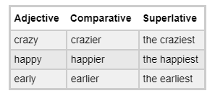

* It was **the happiest** day of my life.
* My joke was **funnier** than your one.
* This section is **easier** than the rest.

### Adjectives with Two or more Syllables

For Adjectives with 2 syllables (that don't end in -y) and higher (3, 4 syllables etc), we use **more** for comparatives and **the most**for superlatives.

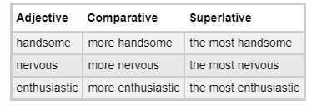

* My girlfriend is **more beautiful** than yours.
* Alex is **more intelligent** than you but I am **the** **most intelligent**.
* It was **the most wonderful** day I have ever had.

Some exceptions with two-syllable adjectives ending in -er and -est:

narrow - narrower, simple - simpler, quiet - quieter

### Irregular Forms

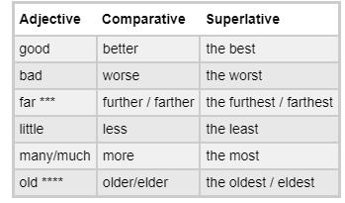

* 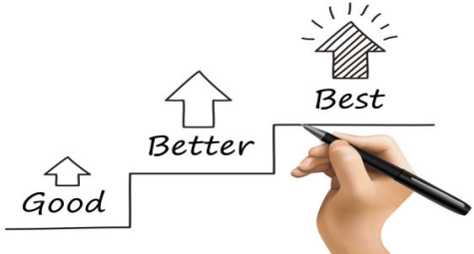 am a **better** tennis player than you but Marcelo is **the best**.
* Steve is a **worse** liar than me but Adrian is **the** **worst**.

**\*\*\* Farther - Further**

Further / farther, furthest / farthest are all used for distance.

Only Further / furthest are used to mean 'additional' or 'more advanced'.

* Puerto Montt is **further / farther** than Valdivia is from here (in Santiago).
* If you require **further** information, please contact reception.

**Remember** that the opposites of 'more' and 'most' are '**less**' and '**least**', respectively.

**\*\*\*\* Older - Eldest**

We use **elder / eldest** when we are talking about family relationships and normally only before a noun (not by itself unless it is a pronoun).

* He is my **elder** brother. (We **cannot** say: My brother is elder than me. - incorrect)
* The **eldest** sister would pass on her dresses to the younger one.

**Comparative and Superlative of ILL**

When comparing how **ill** people are, you will normally hear **worse** or **the** **worst** and not "**iller**or **illest**". Some people may prefer to replace **ill** with **sick** (sicker, sickest) when comparing.

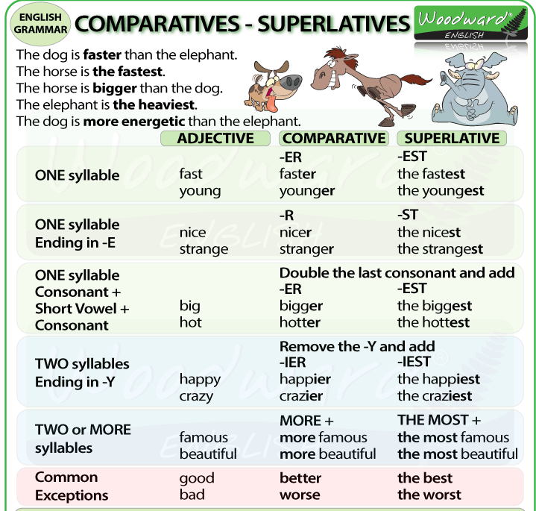

**Write the comparative and superlative forms of the adjectives below.**

|  |  |  |
| --- | --- | --- |
| Adjective | Comparative | Superlative |
| tall | taller | the tallest |
| far | farther/ further | the furthest/ the farthest |
| cheap | cheaper | the cheapest |
| bad | worse | the worst |
| expensive | more expensive | the most expensive |
| fat | fatter | the fattest |
| good | better | the best |
| interesting | more interesting | the most interesting |
| lazy | lazier | the laziest |
| narrow | narrower | the narrowest |
| pretty | prettier | the prettiest |
| safe | safer | the safest |
| beautiful | more beautiful | the most beautiful |
| dangerous | more dangerous | the most dangerous |

|  |  |  |
| --- | --- | --- |
| difficult |  |  |
| messy |  |  |
| boring |  |  |
| handsome |  |  |
| attractive |  |  |
| happy |  |  |
| delicious |  |  |
| short |  |  |
| useful |  |  |
| famous |  |  |
| easy |  |  |
| comfortable |  |  |
| lucky |  |  |
| ugly |  |  |
| quiet |  |  |
| warm |  |  |
| noisy |  |  |
| long |  |  |
| modern |  |  |

****B. Complete the following sentences with the correct form (comparative or superlative) of the adjective provided.

1.- My sister is _____________ my brother. (intelligent)

2.- The blue whale is ____________ animal. (big)

3.- Iceland is ___________ Spain (cold)

4.- This is ___________ book I’ve ever read. (good)

5.- My neighbour is _________ person I know (lucky)

6.- Friday is the __________ day of the week. (busy)

7.- These trainers are much ____________ those. (cheap)

8.- Frank works __________ most people. (hard)

9.- I’m __________ at English than you. (good)

10.- Today has been _________ day of the year. (hot)

11.- This is __________ CD I’ve ever listened. (bad)

12.- English is __________ Japanese. (easy)

13.- Which mountain is ___________ in the world. (high)

14.- John is _________ his brother. (clever)

15.- English is _________ Latin. (useful)

16.- What is ___________ word in English? (common)

17.- The Nile is ___________ river in the world. (long)

18.- This is my __________ brother. Mary is their _________ daughter (old, old)

19.- That skyscraper is one of __________ buildings in the city. (tall)

20.- The first exercise was easy but this one is ________. (difficult)