

**(Assignment 1)**

**Microsoft Excel**

**Name: 1st Semester 2022/ 2023**

**Date: Grade 7 – Section ………**

**You are going to plan a picnic for the 7th grade class. Your responsibility is to come up with a menu and prepare a budget detailing all of the items needed for the picnic.**

Create a new spreadsheet model. The top of the spreadsheet must look like this:

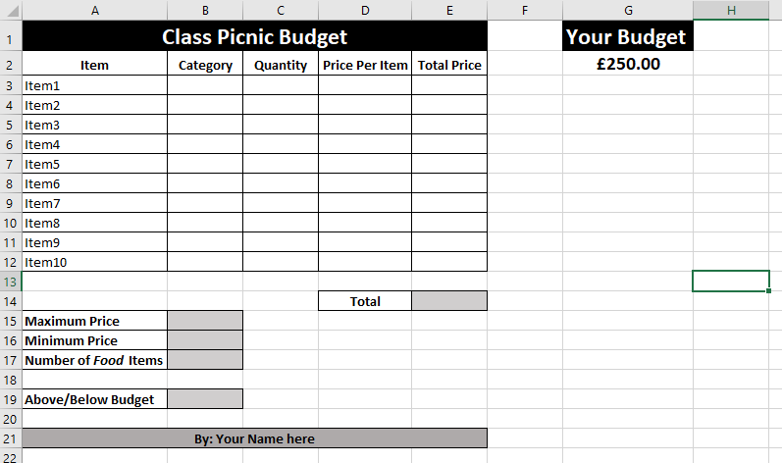

Save the spreadsheet with the name **Picnic_YourName.xlsx**

1. Rename sheet1 to **Picnic**.
2. In the **Item** Column, add 10 items needed for the picnic.
3. In the **Category** column add the category of each item.

(for example: Drink / Food/ Transportation/ Entrance Fees/ clothes/ etc…)

1. In the **Quantity** column add the quantity needed from each item.
2. In the **Price Per Unit** column add the price of each item.
3. In the **Total Price** column use a formula to calculate the **Total** **Price** for each item (Quantity * Price Per Unit).
4. Format the values in columns D and E as currency (Pound £) with 2 decimal places.
5. In Cell **E4** use a function to calculate the **Total** Price of all the items.
6. In cell **B15** use a function to find the **Maximum Price** between the items.
7. In cell **B16** use a function to find the **Minimum Price** between the items.
8. In cell **B17** use a function to count the number of food-category items.
9. In cell **B19** use a function to Display the word “**Above**” if the total price in cell **E14** is greater than the budget in Cell **G2**, and the word “**Below**” if not.
10. Create a vertical bar chart to compare the quantities needed from each item.

Fully label your chart.

Place the chart in a new sheet named: **Chart**.

1. Save your spreadsheet.