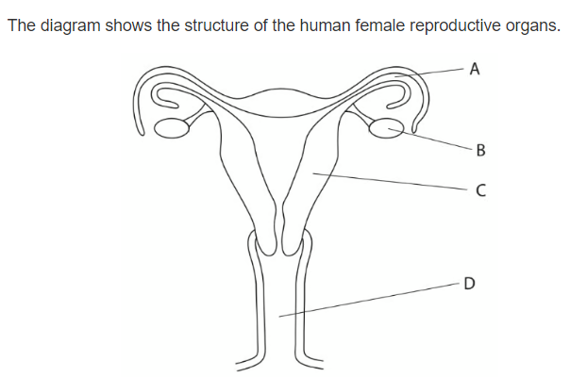**Question 1 :**

* Which letter represent the site of fertilization ………………….
* Which letter shows were the fetus usually develop …………………….
* Name organs :

B : ……………………………

A : …………………………….

C : …………………………….

* Draw an x on the diagram to show where implantation takes place .
* State what is meant by the term menstruation .

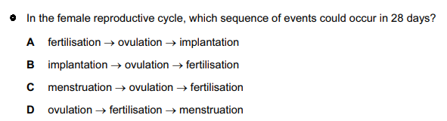…………………………………………………………………………………………………….

**Question 2 :**

1. Khalil is one of three boys , his parents are expecting another child and they are certain it will be a girl . Explain why they are wrong ? *( 1 marks )*

……………………………………………………………………………………………………………………

………………………………………………………………………………………………………………………

1. Copy and complete the diagram to show how the sex of the baby is inherited.

*( 4 marks )*

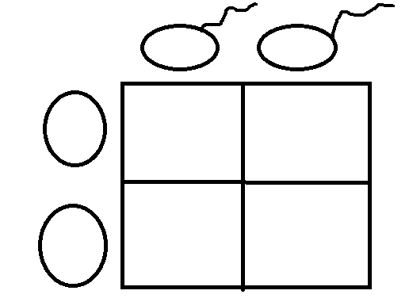

**Question 3 :**

Arrange these objects in size order, starting with the largest. *( 2 marks )*

Nucleus chromosomes gene cell DNA

………………………………………………………………………………………………………………………..

**Question 4 :**

The diagram shows an egg, a sperm and a fertilized egg. *( 3 marks )*

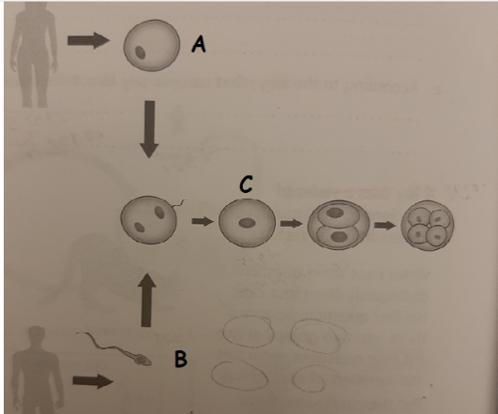Label the diagram to show how genes from each parent get into all an embryo’s cells

**Question 5 :**

Demonstrate how an egg cell is adapted to its function .

…………………………………………………………………………………….

…………………………………………………………………………………….

……………………………………………………………………………………