**Question one** *:*

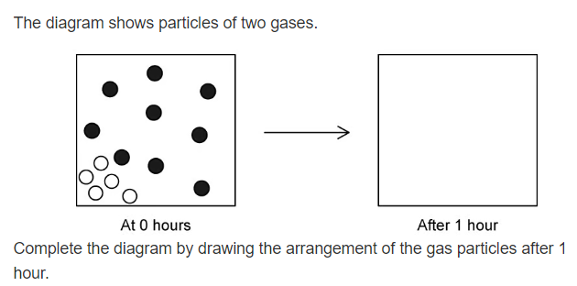

b. Explain your answer in a.

…………………………………………………………………………………………………………………………………………………………………………………………………………………………………………………………………………………………………………………………………..

c. Describe an example of where diffusion of gases is important in the human body .

……………………………………………………………………………………………………………………………………………………………………………………………………

**Question two** *:*

**Decide if the following sentences are true of false .**

1. If the concentration of urea in your blood gets too high , it damages other organs including your brain.(……………….)
2. The liver is an excretory organ it helps in excretion.(………………)
3. The digested food moves into your blood from your digestive system by diffusion against a concentration gradient.(………………..)

**Question three** *:*

**The diagram represents the urinary system**

1. Label all the missing parts .

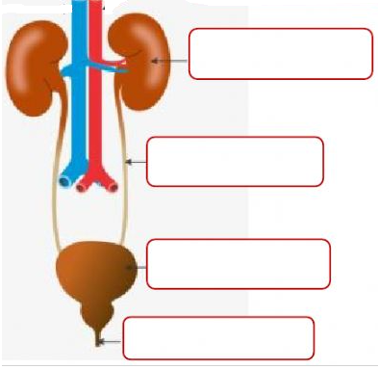

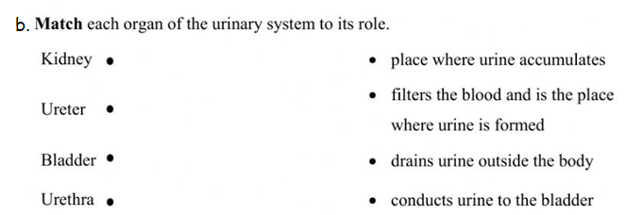

c. Refer back to the diagram to answer the following questions :

* 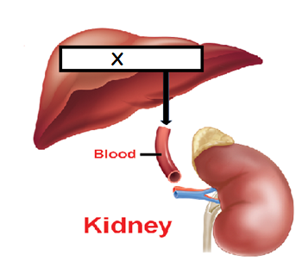Name the substance that is transferred in the blood from part x to the kidneys ………………………………
* Name the process by which this substance is made ……………………………….
* Excretion is important to maintain homeostasis

Give three examples of substances that are excreted out of our bodies .

1. **……………………………….**
2. **………………………………..**
3. **………………………………**