**Question one:**

**Equal volumes of water are placed into three test tubes. Equal sized pieces of metals copper, iron and magnesium are placed into the test tubes.**

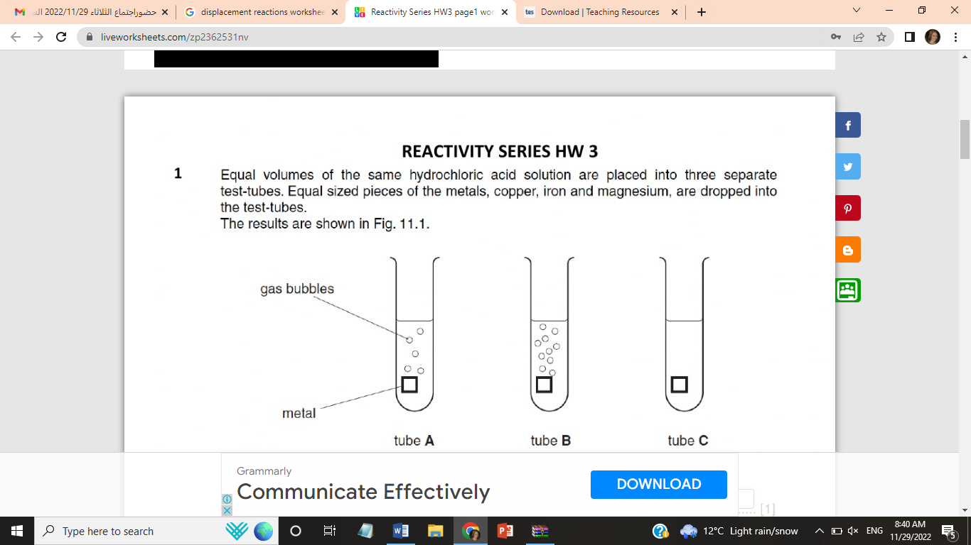

1. **Name the gas produced in test tubes A&B. ....................................**
2. **Which tube contains iron? ...............**
3. **Write the word equation for the reaction of metal A (you have to write the name of metal A in the equation) with hydrochloric acid.**

**...................................................................................................................**

**Question two:**

**Explain how to test the reactivity of a metal with oxygen.**

**……………………………………………………………………………………………………………………………………………………………………………………………………………………………………………………………………………………………………………………………………………………………………………….**

**Question three:**

**A student is planning to investigate the reactivity of four elements (sodium/ gold/ magnesium/ zinc) with water.**

**He decided to test the reactivity of the elements with cold water first, then with hot water or steam.**

**The expected results for the investigation are given in the table below:**

|  |  |  |
| --- | --- | --- |
| **metal** | **Reaction with cold water** | **Reaction with steam OR hot water** |
| **Zinc** | ......................... | Fast reaction, forming bubbles and changing the color of the litmus indicator |
| **Sodium** | Vigorous reaction, rapid change in color of the indicator, fizzing on the surface, a gas given out |  |
| **Gold** | No reaction | No reaction |
| **Magnesium** | reacts slowly forming small bubbles on the surface of the ribbon. | burns in steam to produce white powder and a gas |

* **Where in the periodic table you find the least reactive element? ..............**
* **Fill in the missing results for zinc.**
* **Which is more reactive with water, sodium or magnesium? ...............**
* **Name a metal that is less reactive than sodium but more reactive than magnesium. ...........................**
* **when zinc reacted with hot water, the student observed a change in the color of litmus paper. What causes that change?**

**........................................................................................................................**