**Question one:**

**Marble chips react with dilute hydrochloric acid.**

**CaCO3        +         HCl       →        CaCl2        +        H2O       +        CO2**

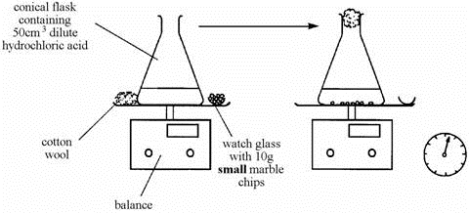**A student wanted to find out if the size of the marble chips made a difference to how fast the reaction took place. She used powdered marble chips as shown below:**

1. What is the name of these compounds:

**CaCO3 ………………………… CaCl2 …………………………….**

1. What readings should she take during the test?
2. ....................................................... 2. …………………………………

**She repeated the experiment but this time used large marble chips.**

1. What variables must be controlled to make it a fair test? …………………………………………………………………………………………………………………………………………………………………….………………………………………..………………

**These are the results of the two experiments.**

|  |  |  |  |  |  |  |  |
| --- | --- | --- | --- | --- | --- | --- | --- |
| **TIME (seconds)** | 0 | 20 | 40 | 60 | 80 | 100 | 120 |
| **Mass loss (g), using small chips** | 0.00 | 0.40 | 0.72 | 0.91 | 1.04 | 1.04 | 1.04 |
| **Mass loss (g), using large chips** | 0.00 | 0.28 | 0.52 | 0.70 | 0.84 | 0.94 | 1.04 |

1. Explain the reason of the mass loss in the two experiments. .............................................................................................................................................
2. Complete the table below

|  |  |  |
| --- | --- | --- |
|  | **Using small chips** | **Using large chips** |
| **Time taken for the reaction to be done (sec)** |  |  |
| **mass loss (g)** |  |  |

**Question two:**

**Two 10g samples of marble of different sizes, A and B, were each reacted with 50 cm3 of diluted hydrochloric acid. The mass of carbon dioxide formed in each reaction was recorded and plotted to produce the graph below.**

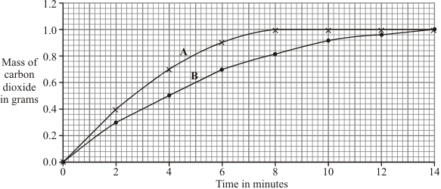

1. Fill in the table below:

|  |  |  |  |
| --- | --- | --- | --- |
|  | **Describe the surface area (small/ large)** | **Time to finish reaction/ min** | **Mass of CO2 produced/ g** |
| **Sample A** |  |  |  |
| **Sample B** |  |  |  |

1. The two lines are both steepest at the start, but A is steeper, which means that reaction A finishes first and (choose the correct answer):

* its rate is slower than reaction B
* its rate is faster than reaction B

1. Explain the results of the investigation, in terms of particles and collisions.

………………………………………………………………………………………………………………………………………………………………………………………………

**Question three:**

**Some students were investigating how fast hydrogen gas is released in the reaction between magnesium and hydrochloric acid.**

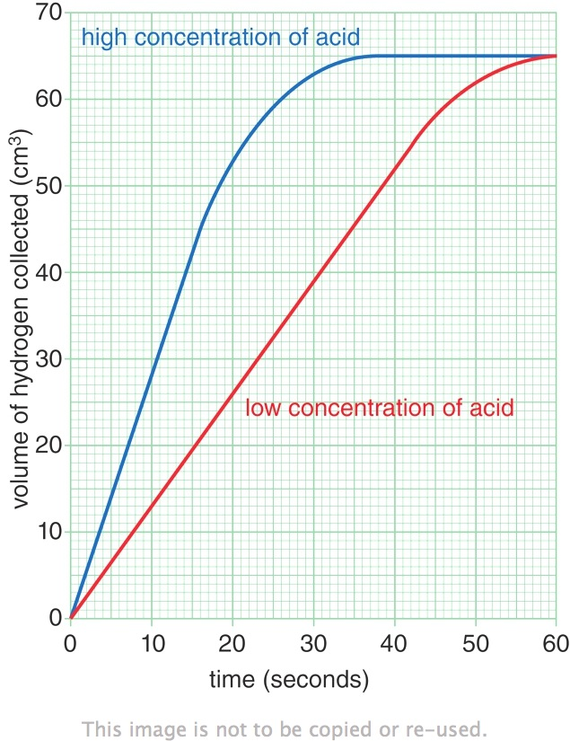**They used 0.1 g of magnesium ribbon with specific volume of diluted acid.**

**Next, they repeated the experiment using magnesium ribbon with the same volume of concentrated acid.**

**Their results are shown on the graph.**

1. Identify:

* The dependent variable: ……………………………….
* The independent variable: ………………………………

1. Use the information on the graph to describe one way in which the two reactions are similar.

......................................................................................................................................

1. Use the information on the graph to describe one way in which the reactions are different.

......................................................................................................................................

1. The faster reaction was caused by using a concentrated acid. Explain, in terms of particles and collisions, why a higher concentration acid causes a faster rate of reaction.

...............................................................................................................................................

..................................................................................................................................................