

**Microsoft Excel -Worksheet1**

**Name: 2nd Semester 2022/ 2023**

**Date: Grade 6 – Section ………**

**Objective –** Validation rules, sorting and filtering data.

* Use appropriate software to create a new spreadsheet (MS-Excel).
* Use the instructions below to create the following table.

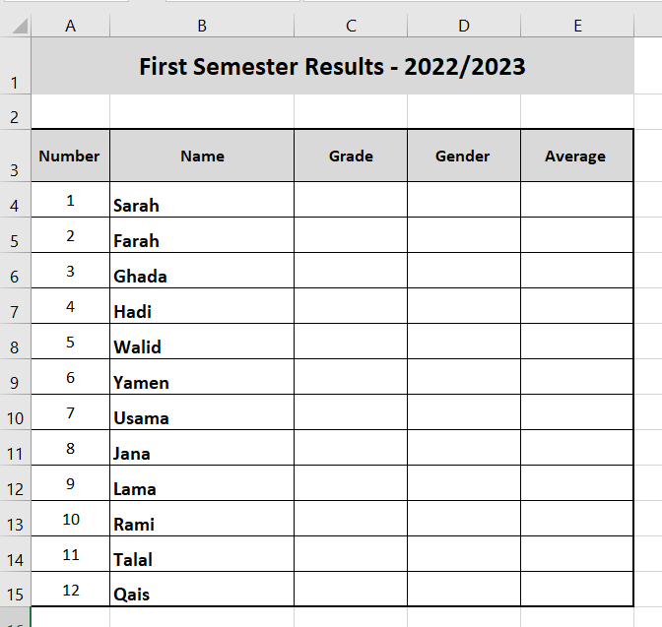

* 1. Merge the range [A1:E1].
  2. In the merged range, change the fill color to be Blue.
  3. Change the row height for Row#1 to 40 points.
  4. Set the text “First semester results – 2022/2023” size to 16, Calibri, bold.
  5. Align the text “First semester results – 2022/2023”: Center and Middle.
  6. Set the text in the range [A3:E3] to: Calibri, 12, Bold, center, middle.
  7. Fill the range [A3:E3] with a blue shade.
  8. Add a border to the range [A3:E15].
  9. Set the width of column B to 25 points.
  10. Set the width of the columns: C, D, and E to 12 points.
  11. Select the range [A3:E15] and then: select Data🡪 Filter.
  12. Sort the data in the table **alphabetically** from (A🡪 Z) according to **student name.**
  13. The data in the range [C4:C15] must be restricted to a whole number, between 6 🡪 8.
  14. The data in the range [D4:D15] must be restricted to [Male/Female].
  15. The data in the range [E4:E15] must be restricted to a whole number, between 0 🡪 100.
  16. Fill the table with data.
  17. In the cell B17 add the text: Created by **your *name***.
  18. Save the file