# D:\Diala دولي\نماذج تصوير للحساسية الضوئية\NOS-Shmaisani E. B&W.png

**Second -Exam**

**Microsoft Excel**

**Name: 1st Semester 2022/ 2023**

**Date: Grade 6 – Section ……..**

1. Create a new excel workbook.
2. Save the workbook using your name.
3. Design a table as in the following image, the notes below may help: -

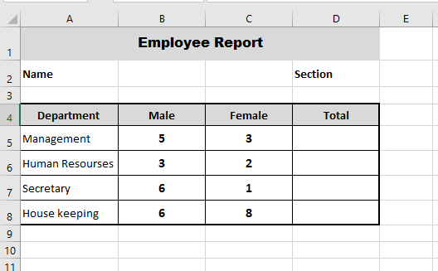

* Merge the range (A1:D1)

Add a grey shade to the range (A1:D1).

Type the title (Employee Report) and set the font size: 18, font type: Calibri, Bold, middle and center.

* In cell A2, type your name.
* In cell D2, type your section.
* Add a grey shade to the range (A4:D4) and type the text that appear in the image above.

Set the font size: 16, font type: Calibri, Bold, middle and center.

* Fill the table with the given data.
* Add a border to the range: [A4:D8].

1. In cell D5 use a function to find the total of Male and Female.

Replicate the function over the range [D5:D8].

1. Create a Pie chart to show the percentage of **Male** employees in each department.
   1. Add a chart title “Male %”.
   2. Display the percentage in each sector.
2. Save your file.