

## Let us forgive each other – only then we will

## live in peace

Worksheet (3) Unit One

Future Will

Grade (4)

Name: Date: / /2022

|  |
| --- |
| **Objectives:**  1. To identify the future simple using will.  2. To practice using will to talk about the future. |

**Key Words :**

Tomorrow, today, later , in five minutes , on Saturday afternoon, Next year-day-month….etc

**Future Will Form:**

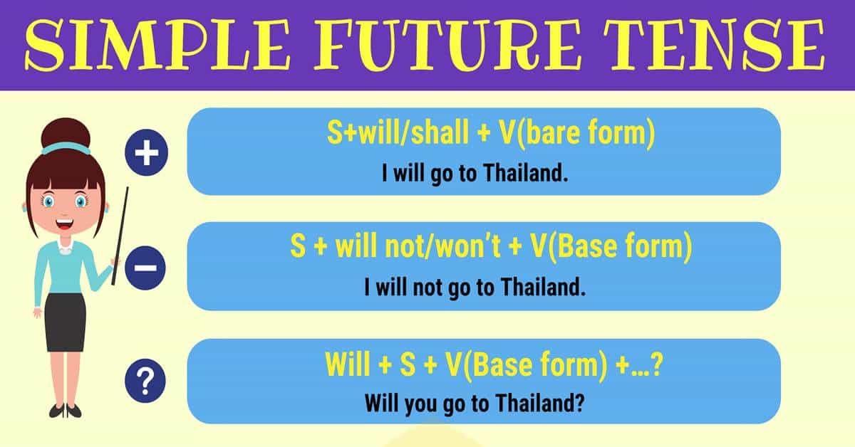

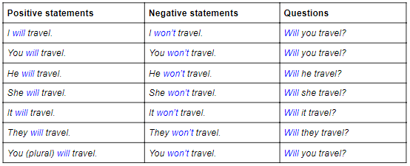

**We use simple future to (Usage):**

1. **Say something will happen in the future .**

I will go to the market tomorrow.

1. **To make promises.**

I will be there at 7 p.m. I promise .

I will do it for you I promise.

1. **To request help or to offer help .**

Will you …..?

Will you help me please to do my homework?

1. **To predict future events.**

I think it will rain tomorrow .

____________________________________

**Q1 )**

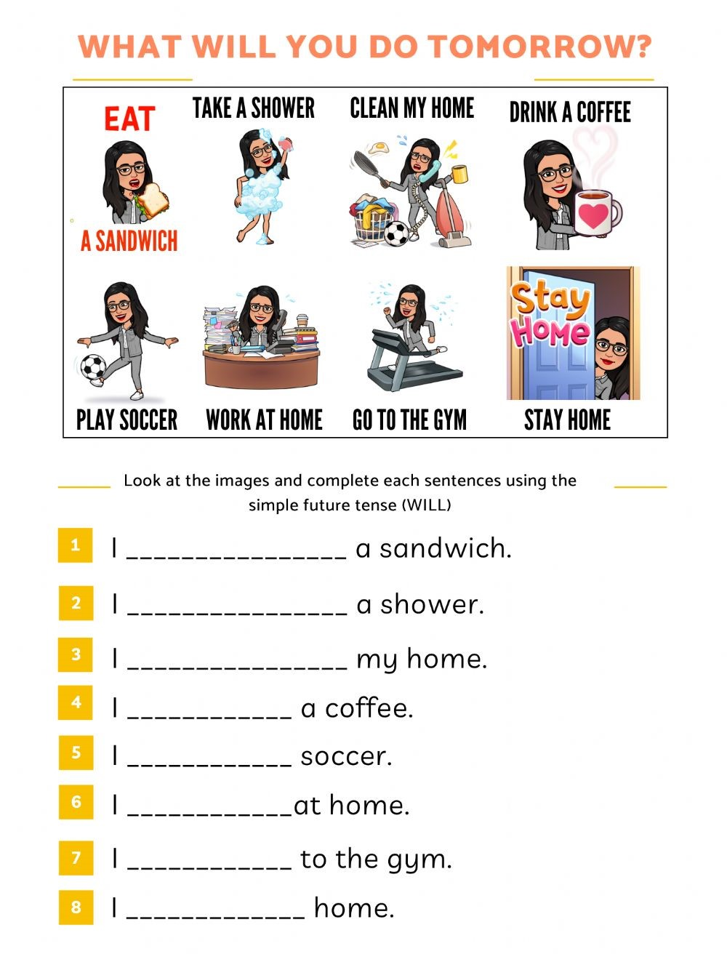

**Q2 ) Write the correct future form of the verb** , **use** (will).

1. Wait, I will help you **.( help)**
2. He won’t probably come back tomorrow**.( come- not )**
3. I will watch TV tonight . **(watch)**
4. It will rain tomorrow. **(rain)**
5. Will you ask him ?**(ask)**

**Q3) Rewrite these sentences in the simple future tense.**

1. I buy a new car next month .

I will buy a new car next month .

1. We learn English this month .

We will learn English this month.

1. They watch TV tonight .

They will watch TV tonight.

1. I travel to Turkey next summer.

I will travel to Turkey next summer.

**Q4) Change these sentences into question and negative sentence .**

**Ex**: They will visit my friend today.

**Negative** : They won’t visit my friend today .

**Question** :Will they visit my friend today ?

1. She will go to the mall tonight .

Negative :She won’t go to the mall tonight.

Question: Will she go to the mall tonight

1. We will come to Jordan next year.

Negative: We won’t come to Jordan next year.

Question: Will we come to Jordan next year ?

1. The robot will win the race .

Negative: The robot won’t win the race.

Question: Will the robot win the race ?

1. I will read a new book next week .

Negative: I won’t read a new book next week .

Question: Will you read a new book next week ?

**Q5) Why do we use will in each sentence.**

1. I think it **will rain** later so, take an umbrella with you . **To predict future events**
2. I promise you , I **will do** my best to help you . **To make promises**
3. **Will** you **carry** the bag for me ,please ? **To request help**
4. He **will turn** to Jordan next year in December . **Say something will happen in the future .**
5. **Will** you **pass** me the pen, please ? **To request help**

Teacher : Raneem Haddad

Coordinator’s Signature : _________________.