 Practice Paper Unit ( 1 )

Grade (4)

Name: Date: / /2022

|  |
| --- |
| **Objectives:**  1. To identify the meaning of the new words.  2. To identify the synonym of the new words.  3. To use the new words in meaningful sentences. |

|  |  |  |
| --- | --- | --- |
| **Verbs** | **Meaning** | **Synonym** |
| **Floating** | To flow  **Example**:  The boy was **floating** his boat. | Flow |
| **Dwelled** | To stay in a place.  **Example**:  He **dwells** in the mountains*.* | Stayed / Lived |
| **Appeared** | To be seen.  **Example**:   The bus **appeared** round the corner. | To be seen. |
| **Observe** | To notice .  **Example**:  The parents observed that their child enjoyed music. | To notice . |

|  |  |  |
| --- | --- | --- |
| **Realize** | To know .  **Example**:   I didn't **realize** you were so unhappy. | To know |

|  |  |  |
| --- | --- | --- |
| **Nouns** | **Meaning** | **Synonym** |
| **Telescope** | A tube with special glass inside it.  **Example:**  Charles had a powerful **telescope**. |  |
| **Observatories** | A building where scientist can look at stars.  **Example**:  Dani visited many **observatories**  last year. |  |
| **Universe** | World  **Example**:  It's a book about the origin of the **universe**. | World |
| **Meteorite** | A piece of rock from the space that hits the Earth.  **Example**:  A **meteorite** travelled from Mars to the Earth last year. |  |
| **Spacecraft** | A ship designed to travel in a space.  **Example**:  Once in their orbiting spacecraft, they will circle the Earth once every 90 minutes. | ship |
| **Asteroids** | A small planet that goes round the sun.  **Example**:  **Asteroids** are huge rocks that move around the sun. | Small planet |
| **Comets** | A bright star with a tail that moves round the sun. | bright star |
| **Disk** | A round , flat object. | Round plate |
| **Speck** | A very small spot, mark, or piece of something .  **Example :**  The moon looks like a speck in the sky . | Spot |

|  |  |  |
| --- | --- | --- |
| **Adjective** | **Meaning** | **Synonym** |
| **Powerful** | Strong.  **Example:**  The race car has a **powerful** engine. | Strong |
| **Tiny** | Very small  **Example**:  Her dolls live in a **tiny** house. | Very small |
| **Vast** | Great  **Example** :  It is a **vast** desert. | Great / Huge |

|  |  |  |
| --- | --- | --- |
| **Adverb** | **Meaning** | **Synonym** |
| **Indeed** | Truly  **Example**:  Her white wooden house was tiny, indeed. | Truly |

|  |  |  |
| --- | --- | --- |
| **Preposition** | **Meaning** | **Synonym** |
| **Beyond** | Outside the ability or limits of.  **Example**:  The house is **beyond** the bridge. | Outside |

**Q1) Put these sentences into the correct order.**

1. 1. Bella / lived / house / wooden / white /in /a .

Bella lived in a white wooden house .

1. Charles / had / telescope / a / powerful.

Charles had a powerful telescope.

**Q2) Match each word with its synonym.**

1. Indeed a. stayed
2. Powerful b. Truly
3. Floating c. To flow
4. Universe d. World
5. dwelled e. Strong

|  |
| --- |
| 1.---b----2.---e----3.----c----4.-----d-----5.-----a----- |

**Q3) Write the correct word under each picture.**

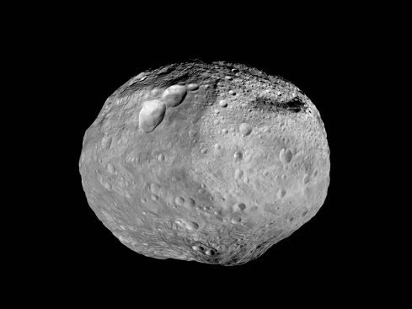

1.  2. 3.

telescope Floating asteroid



1. 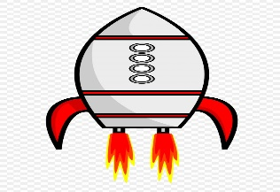 5. 6.

Spacecraft Strong Tiny

**Q3) Complete the sentences using the words in the box.**

|  |
| --- |
| powerful , realize, universe , dwelled , floating , appeared |

1. They didn't **realize** the danger they were in.
2. The race car has a **powerful** engine.
3. It's a book about the origin of the **universe.**
4. The fog cleared away and the full moon **appeared**.
5. He **dwelled** in a small country for one month .

**Teacher : Raneem Haddad**

 Practice Paper /Meaning worksheet

Grade (3)

Name: Date: / /2020

**Objectives**:

* To identify the meaning of the new words.
* To identify the synonym of the new words.
* To use the new words in meaningful sentences.

**Pre-learning**

Student will receive a worksheet that have the new words. They read it carefully and try to understand the meaning threw out picture in Arabic.

**Dear students:**

Kindly , you’ve received a meaning worksheet . Read it and try to look up the meaning of the words that you don’t know in Arabic .

**Procedures:**

*T. read the words and asks sts to help read them in order. Sts discuss the meaning together and read the example sentence. sts take notes.

* T. gives card with pictures and sts trying to guess the words.T. elicit the new vocabs

* Sts trying to make their own sentence.

T* T. go the worksheet and elicit the answers.

T. Gives a power point vocabulary game.

**Attachment :**

**Power point game**